**Deforming Space:**

**Creation of a Non-Euclidean Render Engine**

Jose L. Redondo Tello

Image Processing and Multimedia Technology Centre, Polytechnic University of Catalonia

Bachelor’s degree in Video Game Design and Development

Mr. Marc Garrigó

June 24, 2021



# Introduction

## Abstract

In this document I will explain the development of a real-time non-Euclidean render engine, which will use the ray tracing rendering technique in order to represent deformations of the virtual space in the scene through the use of aberrations.

This project was developed in Visual Studio, using a self-made 3D render engine powered by OpenGL 4.3, and written entirely in C++.

Due to the complexity of the topic and time constrains, this will be a technical demo, focused on showcasing the interesting space/level/puzzle design options that afford non-Euclidean spaces, created and displayed using the scene edition functionality of the rendering engine.

Github release:

## Key words

Non-Euclidean geometry, ray tracing, ray casting, ray path tracing, real-time, C++, OpenGL, GLSL, scene editor

# Preface

## Motivation

Graphics programming is a fascinating subject which I have been studying on my own for the last 2 years, but it wasn’t until I stumbled upon a YouTube video (Non-Euclidean Worlds Engine, 2018) that I became curious about non-Euclidean geometry.

Compressing the space needed to play a game has been a huge design constrain in VR games. To explore big extensions of terrain, a movement mechanic needs to be implemented with the player’s movement in the real world, these mechanics break the immersion and tend to cause motion sickness. Non-Euclidian spaces can be used to cramp an infinite number of rooms in small spaces via portals and space deformation, thus reducing the weight or even removing the space limitation completely, allowing the creation of more immersive experiences.

The main motivation is to create a render engine capable of rendering non-Euclidean spaces using ray tracing, allowing me to see and interact with aberrations in real time.

## Goals

The main objective of this paper is to develop a rendering engine using C++ and OpenGL, which will be able to render simple scenes in real time using a ray tracing algorithm.

This rendering engine will allow the user to create aberrations, which deform the way the scene is perceived and traversed, either by compressing or expanding the space in the directions the user introduces to the aberration trough the editor.

* Learn and use OpenGL compute shaders.
* Implement ray tracing algorithm.
* Optimize the algorithm and the process to send scene data to GPU.
* Create an aberration component and implement a method to visualize it in engine.
* Deform the rays using aberrations that will deform what the user sees.
* Make aberrations interact with the camera movement.
* Make the aberrations able to change not only the direction of the rays, but also their position (portals).
* Create a demo to showcase and explore its possibilities.
* Document the development process for future researches.
* Showcase the new possibilities and advantages of using non-Euclidean spaces.

## Problem description

The use of non-Euclidean spaces in video games, despite not being new, hasn’t seen a big progression outside of some notable indie games (*Superliminal*) that decided to go a step beyond simple portals that seamlessly teleport the player to a different location.

This can be attributed to the lack of resources and recorded projects that accomplished other forms of non-Euclidean spaces and the lack of knowledge about the possibilities enabled by them.

One example of a video game sector that would benefit from using non-Euclidean spaces is VR games, where the fact that the user is in a closed space obliges the developers to add level traversal mechanics (teleport, movement through joystick…) that may break the immersion and cause motion sickness. Non-Euclidean spaces make possible to compress an infinite amount of space into a single room.

Showcasing the design space that non-Euclidean spaces create and give the tools to developers to test and experiment about the effects and experiences that can be archived may help expand and diversify their uses.

## Scope

The objective is to create a demo which will showcase scenes with different non-Euclidean spaces, showcasing some design possibilities and the interactions with these spaces. The demo will not have the ability

Note that the goal is to create a rendering engine, not a game engine, which means that features such as scripting / gameplay features, nor will it have the ability to render complex scenes with hundreds of objects with thousands of polygons.

It will contain basic level editor tools to add, import, rotate, move and scale meshes, and the capability to create, rotate, scale and move aberrations, whose effects on the space will be defined by parameters introduced by the user.

These aberrations will change the direction and the position of the rays thrown by the camera and will affect its movement, thus effectively deforming the space of the scene. Spherical and hyperbolic geometry will not be supported (different types of non-Euclidean geometry), since they require a different implementation and treatment.

**Table of contents**

List of figures 9

Glossary 10

Dictionary 10

Acronyms 11

Project management 12

Planning 12

September 2021 12

October 2021 12

November 2021 12

December 2021 – January 2022 13

February 2022 13

March – April 2022 14

May 2022 14

Organization tools 14

SWOT Analysis: 15

Risks and contingency plans 15

Logistic problems 16

Programming for the GPU 17

Ray tracing 18

Non-Euclidean geometry 18

Methodology 19

Methodology type 19

Requirements 19

Design 19

Implementation 19

Verification 20

Cleaning & Optimization 20

Verification 2 20

Tools for monitoring the project 21

Result validation method 22

Target hardware 22

Validation 22

Theoretical Framework 23

Ray tracing 23

Algorithm 23

Compute shaders 24

How to implement it 24

Optimizations 25

Euclidean geometry 26

Non-Euclidean geometry 26

State of the art 27

Ray tracing 27

Non-Euclidean geometry in Games 28

Non-Euclidean rendering engines 30

Visualization of Non-Euclidean Spaces using Ray Tracing (2019) 30

Real-Time non-Euclidean Ray-tracer Demo 31

Non-Euclidean GPU Ray Tracing Test 32

Contribution 33

Project development 34

Requirements 34

Real-time GPU ray tracing algorithm with meshes 34

Aberrations (edition and previsualization tools) 34

Aberration ray deformation and collision detection 34

Camera-Aberration interaction 34

Development: Real-time GPU ray tracing algorithm with meshes 35

Design 35

Implementation 36

Cleaning & Optimization 40

Validation 41

Development: Aberrations edition and previsualization tools 43

Design 43

Implementation 44

Cleaning & Optimization 47

Validation 47

Development: Aberration ray deformation and collision detection 48

Design 48

Implementation 49

Cleaning & Optimization 55

Validation 55

Development: Camera-aberration interaction 56

Design 56

Implementation 56

Cleaning & Optimization 57

Validation 58

Conclusions 60

Bibliography 61

# List of figures

**Figure 1 Gantt example** 14

**Figure 2 SWOT** 15

**Figure 3 Waterfall method** 21

**Figure 4 GitHub example** 21

**Figure 5 Ray tracing illustration** 24

**Figure 6 Space partitioning example** 25

**Figure 7 Houdini render example** 27

**Figure 8 Raster vs. Hybrid render comparison** 28

**Figure 9 Portal example** 29

**Figure 10 Visualization of Non-Euclidean Spaces using Ray Tracing caption** 30

**Figure 11 Real-Time non-Euclidean Ray-tracer Demo caption** 31

**Figure 12 CNLohr engine caption** 32

**Figure 13 Compute shader output** 36

**Figure 14 Sphere ray tracing test** 37

**Figure 15 Sphere deformation** 38

**Figure 16 Triangle ray tracing test** 38

**Figure 17 Cube mesh error** 39

**Figure 18 Multiple cube meshes** 40

**Figure 20 Mesh color picker** 41

**Figure 21 House mesh** 42

**Figure 22 Component aberration class UML** 43

**Figure 23 Aberration editor** 45

**Figure 24 Aberration previsualization** 46

**Figure 25 Aberration and mesh collision test** 50

**Figure 26 Unidirectional aberration** 50

**Figure 27 Ray deformation diagram** 51

**Figure 28 Ray radial deformation** 52

**Figure 29 Mirror problem example** 52

**Figure 30 Aberration-ray exit test 1** 53

**Figure 31 Aberration-ray exit test 2** 54

**Figure 32 Aberration-ray exit test 3** 54

**Figure 33 Z deformation tunnel** 55

**Figure 34 Camera inside aberration demo** 58

**Figure 35 Aberration artifact** 59

# Glossary

## Dictionary

**GPU intensive:** Task / program that uses a lot of GPU processing power during an extensive amount of time.

**Algorithm:** An ordered set of instructions recursively applied to transform data input into processed data output, as a mathematical solution, descriptive statistics, internet search engine result…

**Real-time / online render engine:** Engine that renders the scene at a refresh rate high enough to create the illusion of motion (30 FPS and upwards).

**Offline render engine:** Engine focused on the quality of the render, can take hours or days to render one frame of a scene (depending on the scene and effects complexity).

**To render:** To interpret a scene / geometry / object and translate that interpretation to a visual 2D image.

**Ray tracing / path tracing / ray casting:** Rendering technique based on throwing rays for each pixel of a camera, and painting it with the color of the element the ray intersected with.

**Mesh:** Representation of a geometric object as a set of finite elements.

**High-poly mesh:** There is no set number that defines a high-poly mesh, in our case, we will consider a high-poly mesh any mesh with more than 50.000 vertices.

**To debug:** To stop the execution of the code at certain points, to visualize the state of the variables and how the code operates step – by step. Technique used in programming to fix and locate errors.

**Hardcoded variable:** A hardcoded variable is one that cannot be changed in the middle of execution, directly written in the code.

**Diffuse light:** Simulates the directional impact a light object has on an object. This is the most visually significant component of the lighting model. The more a part of an object faces the light source, the brighter it becomes (Vries, 2014).

**Aliasing:** Effect in which the pixel formations in a computer rendered image become visible.

## Acronyms

**GPU:** Graphics Processing Unit, specialized electronic circuit designed to accelerate the creation of images.

**CPU:** Central Processing Unit, electronic circuitry that executes instructions comprising a computer program.

**ND:** N-Dimensional

1. 2D Two-Dimensional
2. 3D Three-Dimensional

**GPGPU programming:** General-Purpose Graphics Processing Unit programming, programming paradigm focused on the possible uses of GPU’s outside of rendering (AI, mathematic computations…).

**VR:** Virtual Reality.

**AABB:** Axis-Aligned Bounding Box.

**FoV:** Field of View.

**FPS:** Frames Per Second.

**UI:** User interface

**UV:** Texture coordinates of a mesh.

# Project management

Due to this project’s high technical difficulty, the planning was understood as a set of deadlines that, in case of not being accomplished, would delay the next implementation, probably causing the need to cut down features.

## Planning

### September 2021

Month dedicated to investigate and understand not only the contents but also the needs of the project, their scale, the different implementations and the problems and consequences of each of them.

With all the sources gathered, at the end of the month a reunion with the TFG supervisor was held in order to assess the order and importance of the features that must be implemented, the optional ones, and the discarded features, and also inform of the implementations of each one and their respective deadline.

### October 2021

Start to implement ray tracing, the first part of the development and the longest one, expected to be completed by the end of February 2022, it was estimated that 4 moths were needed to implement it.

* Set up a compute shader.
* Draw first geometrical shape (sphere) using raytracing algorithm.

### November 2021

Start to make the engine “usable”, focused on testing that the raytracing algorithm, compute shader and geometric math are set up correctly.

* Ray trace a triangle.
* Set up perspective camera.
* Enable automatic FoV adjustments.

### December 2021 – January 2022

The biggest and most important feature of the project is to render a mesh using ray tracing. It is expected to cause a lot of problems due to the need to send a lot of data from the CPU to the GPU. Careful testing will be needed in order to minimize the risk of bugs.

* Send geometry data to GPU through a texture.
* Paint a simple triangle.
* Paint complex meshes.
* Apply transform changes (translate, rotate, scale) form the inspector automatically.

### February 2022

Period dedicated to clean the code and improve it, with the intention to optimize it since the next features are expected to be expensive. Low priority tasks related to ray tracing rendering will be implemented during this month, the ones that are not finished will be discarded from the prototype.

* AABB boxes implementation.
* Fast ray/triangle intersection.
* Clean and optimize the code.
* Change mesh color through inspector (Optional).
* Add textures (Optional).
* Illumination (Optional).
* Shadows (Optional).
* Reflections and refractions (Optional).

### March – April 2022

Start of the second and final phase of the development, focused on implementing non-Euclidean aberrations.

* Aberration inspector previsualization.
* Aberration intersection.
* Ray trajectory deformation.
* Deformations editable through inspector.
* Ray position change (Portals).

### May 2022

This month will be used as a buffer to finish pending tasks, the tasks planned for it have a low workload.

* Add support to save and load multiple scenes.
* Create test scenes to showcase the features and possibilities.

## Organization tools

A Gantt diagram that displays in a high level the state of the project, the order and duration of each task and the deadlines of each feature, created in the application *Agantty* which has a built-in feature to send mails each day/week/month reminding the user of the state of the project.

**Figure 1 Gantt example**

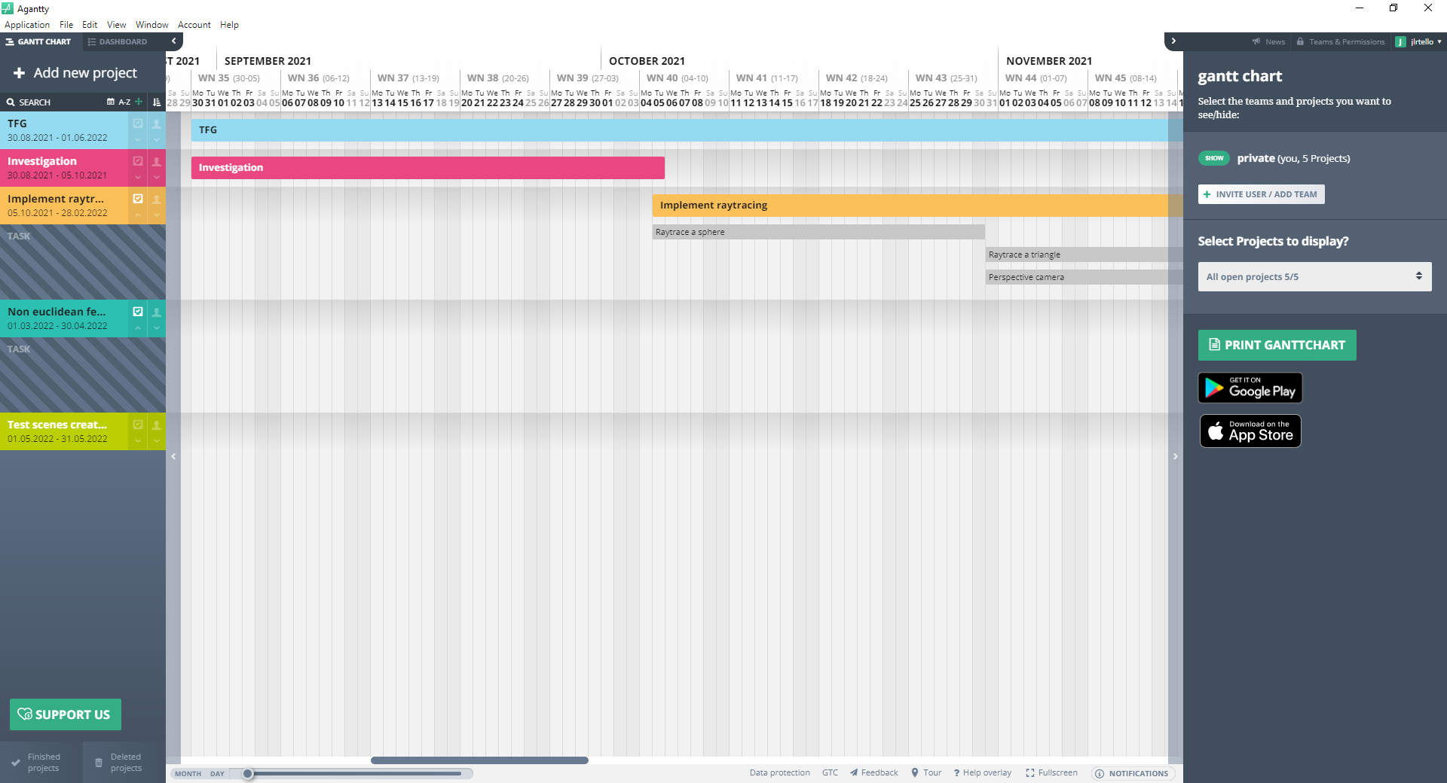

## Cost analysis

The next table displays the different tasks, their time needed for completion, the estimated delays and their costs.

**Figure 2 Personal cost analysis table**

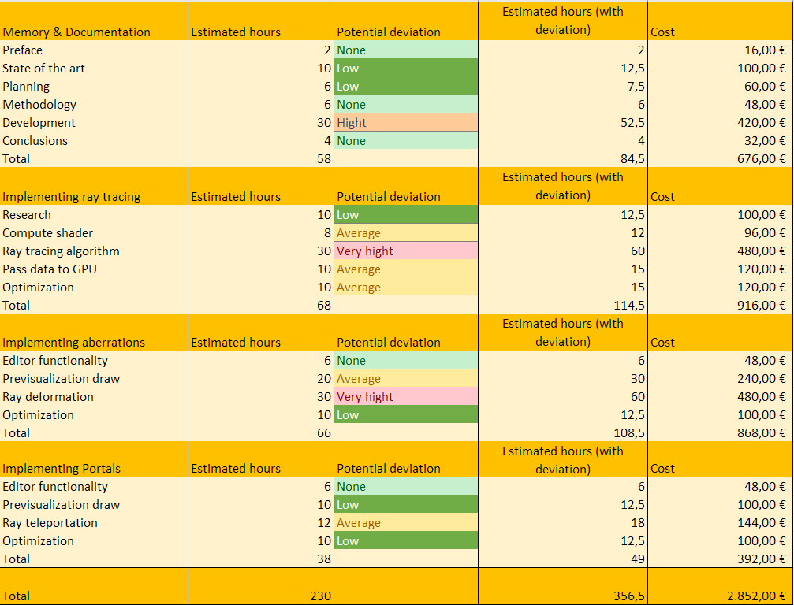

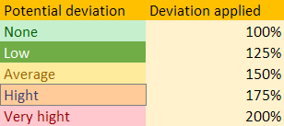

**Figure 3 Cost analysis table**

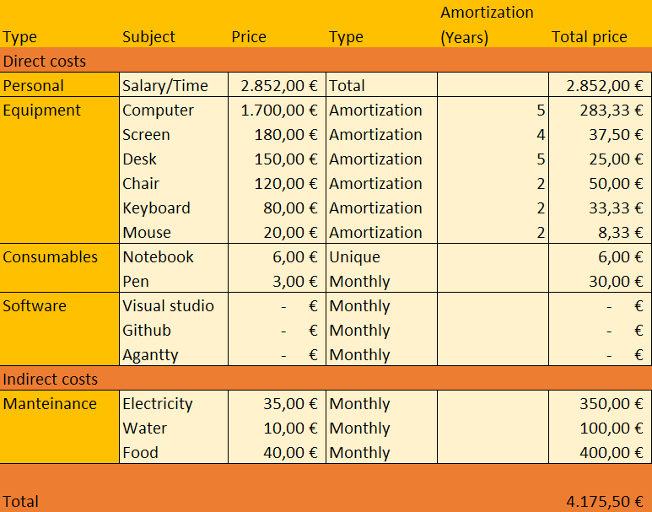



## SWOT Analysis

**Figure 4 SWOT**

|  |  |
| --- | --- |
| **Strengths** | **Weaknesses** |
| Previous experience working with shaders.  Experience handling long term projects.  Self-made engine with free libraries. | Information, algorithms and code has to be adapted to the project.  Lack of experience with GPGPU programming.  Need a high-end computer to use and work on the project. |
| **Opportunities** | **Threats** |
| First non-Euclidean engine that allows multiple mesh objects edition from the inspector.  Student project, which enables the possibility to take risks. | Optimizations may not be enough to allow for real-time rendering.  Hard to escalate the project. |

## Risks and contingency plans

Due to the longevity of this project, taking into account the possible risks during the development was one of the main focuses during the investigation phase, in an attempt to minimize unforeseen problems and have enough resources in case a minor / discarded feature becomes necessary in further iterations of the project.

### Logistic problems

**Lack of resources:** As stated before, the lack of debugging tools and specialized information on the subject make this development prone to experiencing delays due to technical errors and lack of knowledge. This is why a lot of time has been dedicated in researching the topic and learning techniques and utilities outside the scope and objectives of this project, so that any errors or unexpected issues can be addressed without the need to research again. It is also worth noting that, as stated before, there is an entire month dedicated to finish pending features.

**Obsolete hardware:** My current computer is using a GTX 1050, a low profile GPU that I suspect will be below the requirements of this project. An RTX of the 3000 series would be a great purchase, since they have processing units dedicated specifically to accelerate ray tracing operations. Even though it will probably exceed the minimum requirements of the finished project, it will allow me to finish the entire ray tracing code and then optimize it.

**Lack of specialized information:** The majority of information related to ray tracing is focused on offline rendering in the CPU and the information on GPU ray tracing is usually about the algorithm itself and using it to render hardcoded shapes. This is the main reason why the ray tracing development is expected to take 4 months since adapting CPU ray tracing information to GPU and discovering how to send large portions of data to the GPU will be the main challenges of the first development phase.

**Legacy problems:** The base of the project is a raster render engine, created for a university assignment in my third year, due to the lack of knowledge at the time, usability and code structure issues may pose a problem to the development process. Even though it has been revised for the ease of use of the application, and restructured to avoid bugs, it should be taken into account that because of the large code base of the project some problems might go unnoticed for long periods of time.

### Programming for the GPU

GPU programming presents a lot of differences in comparison to CPU programming, even though the programming languages used seem similar on a surface level.

Firstly, the code that is being executed in the GPU cannot be debugged, increasing the difficulty of finding problems and slowing the development of the project, since small problems become really hard to locate.

Secondly, communication between the CPU and GPU is not completely transparent, and different hardware might do different conversions of the same data without noticing the user, causing errors and undesired results.

Lastly, optimizing code for the GPU is a very unintuitive process due to certain functions and operations being highly optimized while others are avoided because they slow down the execution (for example, conditionals and loops). One of the most important parts of optimizations comes down to improving and reducing the communication between CPU and GPU.

### Ray tracing

Ray tracing is a technique that consists on throwing a ray for each pixel of the screen and painting the pixel depending on the color of the object that collided with the ray (the technique will be explained in detail later).

Nowadays the screen size standard for computers is 1920 x 1080 pixels, therefore, using a raytracing render engine that wants to paint all the screen will need to throw at least 2.073.600 rays. This makes raytracing a very GPU intensive algorithm, which has started to see use in the past 4 years thanks to hardware improvements, but only in small and concrete parts of the render pipeline due to it being very slow compared to rasterization rendering.

Though applying ray tracing in a real time engine is possible, it requires a lot of code optimizations and, more importantly, does not allow for high-poly meshes nor complex scenes with a lot of objects.

### Non-Euclidean geometry

Despite a lot of information being available about non-Euclidean geometry, the spaces that can be created and how they interact with rays, there aren’t real time implementations of the concepts described using raytracing rendering and meshes.

# Methodology

## Methodology type

The methodology used for this project is the waterfall methodology. This approach emphasizes a linear progression from beginning to end of a project and relies on careful planning.

The phases considered are:

### Requirements

Research information about the project in order to have a detailed understanding of the project’s requirements, risks and dependencies. What needs to be done in order to complete the project and acquire the desired results.

The main focus of this step is in doing an extensive research on the project necessities and different approaches to complete it, based on understanding previous attempts to solve the problem, scientific papers that could lead to a new solution to the problem or that explain the algorithms and theory needed to proceed with the project.

### Design

Design a technical solution to the established requirements.

Decide how to solve the problem using the knowledge from the investigation done in the previous step, due to lack of experience it is possible that the solution proposed will cause unforeseen problems which will be taken care of in the verification phase.

Multiple different solutions will be designed before implementing the feature in order to minimize time loss when a solution does not meet the requirements.

### Implementation

Create the feature / application.

Process to implement the solution in the application, focused on programing the required feature so that it can be tested. This process will be done gradually and updated to Github as often as possible in order to keep track of what has been done and to enable the possibility to copy previous instances of the application with the objective to track errors or save previous progress.

### Verification

Test the application and its features to ensure all the requirements have been completed.

To consider a feature as “completed” it will need to:

* Be tested in different environments and situations alongside the previously implemented features (save / load scenes, create multiple objects…).
* In case that any bug was found, solving it will become a high priority task.
* If the feature slows down the engine below 30 FPS optimization of the feature will become a high priority task.
* Go through an improvement phase where the code will be cleaned and improved to ensure a good base of code and reduce future risks.
* The feature has to be fully implemented with all of its functionalities

Only when the conditions above are accomplished the task will be considered “completed”.

### Cleaning & Optimization

Clean the code and optimize it in order to facilitate the implementation of future features.

As stated before optimization will be a determining factor to enable the target hardware to run the application in real-time since the calculations that will need to be done are very expensive and have to be done a lot of times.

### Verification 2

Test that the optimizations are working properly and have not generated bugs.

The tests of the verification step will be repeated to ensure that the feature is still functioning properly and special attention will be put in ensuring that the optimization has indeed improved the frame-rate of the application.

Note that the waterfall methodology also considers a maintenance phase, but it will not be taken into account for this project. Instead two new phases were created to ensure a good and optimized code and that the project runs in real-time in as many computers as possible.

**Figure 5 Waterfall method**

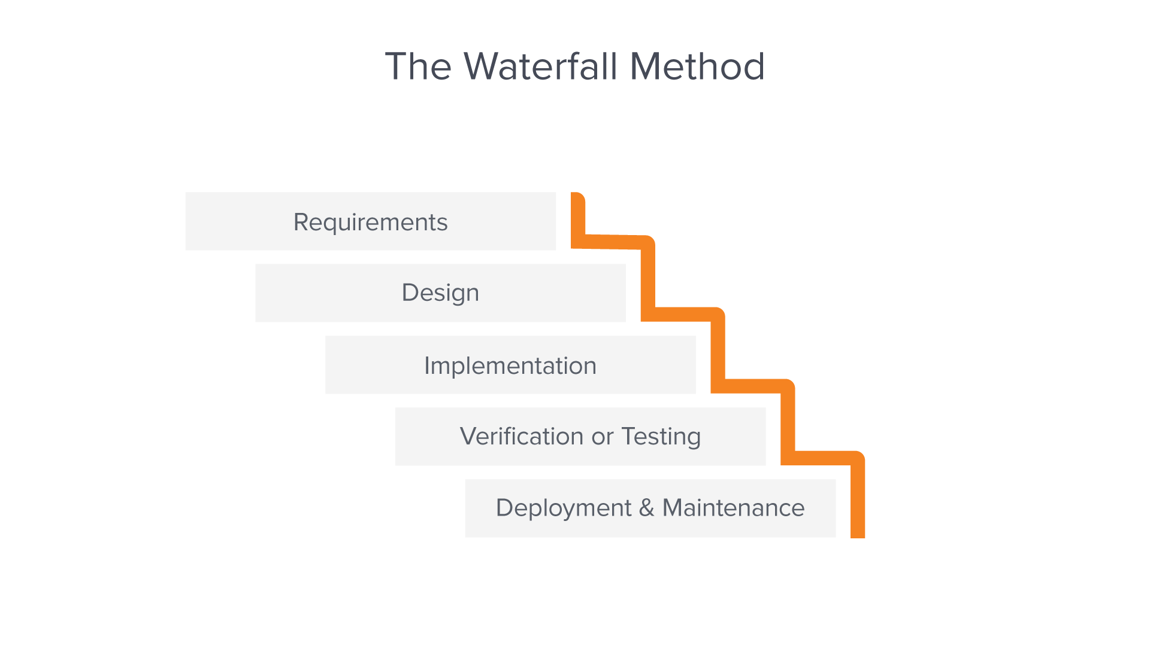

## Tools for monitoring the project

GitHub is the main tool used to monitoring the project, this platform is mainly used to store projects and allow big teams to work simultaneously in the same project.

Since this tool has been used extensively during the career, no investigation and learning were needed to start using it to develop the project.

GitHub page: https://github.com/jose-tello/TelloEngine

**Figure 6 GitHub example**

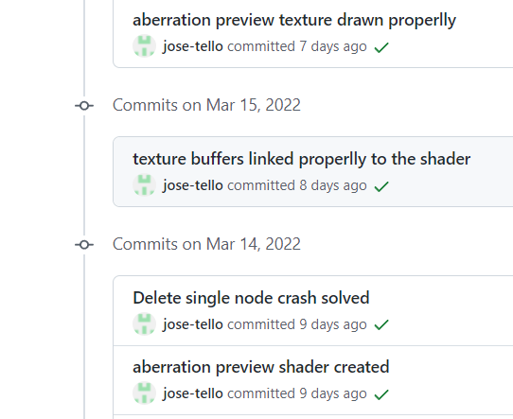

Here we can observe that GitHub lists all the code actualizations in chronological order, it also allows the user to see the changes done in each commit.

## Result validation method

### Target hardware

* Processor: 2.8 GHz
* Graphics card: NVIDIA GTX 1050 TI
* RAM: 16 GB
* System: x64

### Validation

The validation will be done in blocks:

**Real-time GPU ray tracing with meshes:** The application should be able to render simple scenes with primate meshes and meshes added by the user, these scenes should be editable through the inspector in real time using the engine inspector and gizmos. The application should run at a frame-rate higher than 100 FPS in the target hardware.

**Aberration edition and previsualization tools:** The engine should have the tools needed to create, move, rotate, scale and set the values of the aberration deformation on execution using the inspector. And display the position and area of effect of each aberration alongside an option to show the previsualization display.

**Aberration space deformation:** At this point the application should be able to display the effect that the aberrations have on the terrain and affect the camera to further empathize the illusion. The application needs to work at 30FPS in the target hardware.

# Theoretical Framework

## Ray tracing

Ray tracing is a method of graphics rendering that simulates the physical behavior of light (Nvidia, n.d.).

Most used method in offline rendering due to its impressive and realistic results when rendering emissive, reflexive and refractive materials, lightning and shadows, volumes (smoke, fire, clouds…) and fluids (water, lava…).

Started seeing use in real-time engines due to new GPUs that have started implementing technology dedicated exclusively to this technique. Nowadays, even though it’s still too slow to use it in real time, the technique is used alongside the raster render pipeline mainly to create small light reflections, light highlights and clouds.

### Algorithm

This method consists on throwing rays from the origin of the camera to the center of each pixel. Then check what objects intersected with the ray and set the color of the pixel with the color of the nearest object that intersected with the ray (L. Cook, Porter, & Carpenter, 1984).

Once a ray intersects with an object, it will throw secondary rays from the point of collision, in order to evaluate different lightning and material-related effects, such as reflections and shadows. Once the secondary rays have been evaluated (secondary rays could create more secondary rays in order to increase visual fidelity) the resulting colors will be mixed and the resulting color will be set as the color of the pixel.

### Compute shaders

As stated before, the algorithm itself is not slow, the problem is that it has to be done a lot of times. In a 1920 x 1080 screen, we would need to throw 2.073.600 rays to render the scene without light, light effects or shadows, witch’s objects borders would look like the image has low resolution (aliasing). Adding lights (for example) and simple diffuse illumination, would require to double the amount of rays casted into the scene.

Compute shaders are general-purpose shaders that allow to use the GPU for other tasks - GPGPU programming (Gerdelan, 2016). This allows us to use the GPU to execute the same code multiple times in parallel, thus enabling us to calculate various ray intersections at the same time, greatly reducing the execution time.

### How to implement it

Firstly, we will set a compute shader that will render to a texture, which we will then render to a rectangle in our engine (scene window), the compute shader will calculate each ray independently (one ray for each pixel of the texture).

In the compute shader, the pixel position will be remapped to values between -1 and 1, will be used to calculate the direction vector from the camera position to the current pixel of the texture.

The ray will test if it collided with any triangle in the scene, if it does, it will get the color of the nearest geometry it intersected with and paint that pixel with it. If the ray does not intersect with any geometry, the pixel will be painted black.

**Figure 7 Ray tracing illustration**

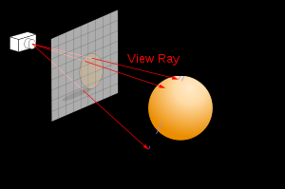

### Optimizations

As stated before, this process is really slow but it can be optimized to a usable state in real-time with enough optimizations.

**Space partitioning:** A mesh can be composed of hundreds or thousands of triangles, and each ray has to check for collisions with every one of them, but as we can see in the next figure, there are situations where the ray does not collide with the geometry, causing to do a lot of unnecessary collision tests:

**Figure 8 Space partitioning example**

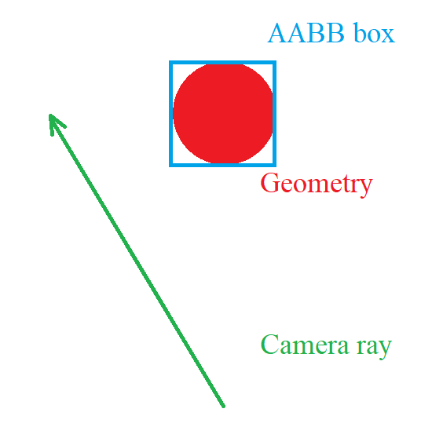

If we simplify each object into an AABB, which are cubes that encapsulate all the geometry of the object. Then we can test if the ray collides with the box of the object, and only testing collision with triangles if the ray intersected with the box, allowing us to quickly discard objects that don’t intersect with the ray.

**Fast ray-triangle intersection:** A lot of research has been done to find the fastest way to calculate if a ray intersects with a triangle with the objective to speed up the raytracing algorithm. The Möller-Trumbore algorithm will be the one used in the project, this algorithm translates the origin of the ray and then changes the base of that vector which yields a vector (*t, u, v*), where *t* is the distance to the plane in which the triangle lies, and (*u, v*) represents the coordinates inside the triangle ( Möller & Trumbore, 1997).

**GPU optimizations:** GPU programming operates very differently compared to CPU programming at a low level, which mainly turns into avoiding if statements and loops thus reducing the clarity of the code. The most problematic and slow operation, however, is when the CPU has to communicate with the GPU.

Textures are the fastest structures that can be sent to the GPU, and extracting their values is also one of the fastest operations in the GPU, thus making it the best method to send large amounts of information from the CPU to the GPU. In our case that would be the geometry of the scene.

All the vertices, all the indices and the texture coordinates are codified as RGB values into 3 textures and sent to the GPU where the compute shader translates the texture data into geometry data, and then calculates the ray intersections.

## Euclidean geometry

Euclidean geometry is a mathematical system based on 5 principles:

* A straight line may be drawn between any two points.
* A piece of straight line may be extended indefinitely.
* A circle may be drawn with any given radius and an arbitrary center.
* All right angles are equal
* If a straight line crossing two straight lines makes the interior angles on the same side less than two right angles, the two straight lines, if extended indefinitely, meet on that side on which are the angles less than the two right angles. (Two parallel lines will never cross).

(Bogomolny, 1996).

## Non-Euclidean geometry

Any type of geometry that does not follow one or more of Euclid’s postulates is considered non-Euclidean (Miller, 2018).

# State of the art

## Ray tracing

This rendering method is the most widely spread in offline renders due to its photo-realistic results and the capacity to handle difficult substances / elements such as smoke, fire, fluids…

Houdini, 3Ds Max, Maya, Blender, RenderMan (Pixar)… Are some of the most advanced 3D edition tools in the market of Animation, 3D modelling and special effects which use render engines based on this technique.

**Figure 9 Houdini render example**

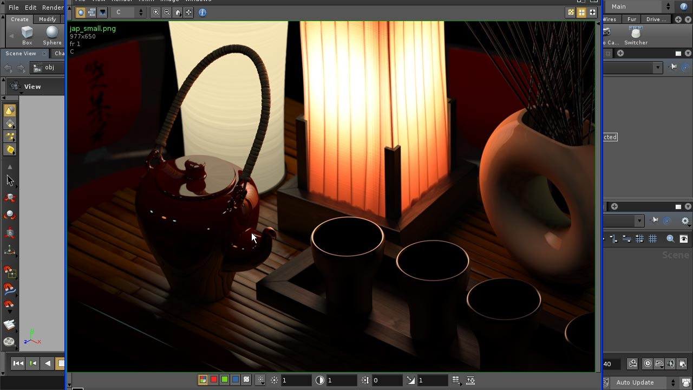

In the past years, as GPU’s have started adding support for raytracing, the method has become fast enough to be used in real-time in hybrid render pipelines where there are 2 render passes, the first pass renders the scene with the raster algorithm, and the second pass renders certain surfaces of the scene with ray tracing (mainly reflections and ambient illumination).

**Figure 10 Raster vs. Hybrid render comparison**

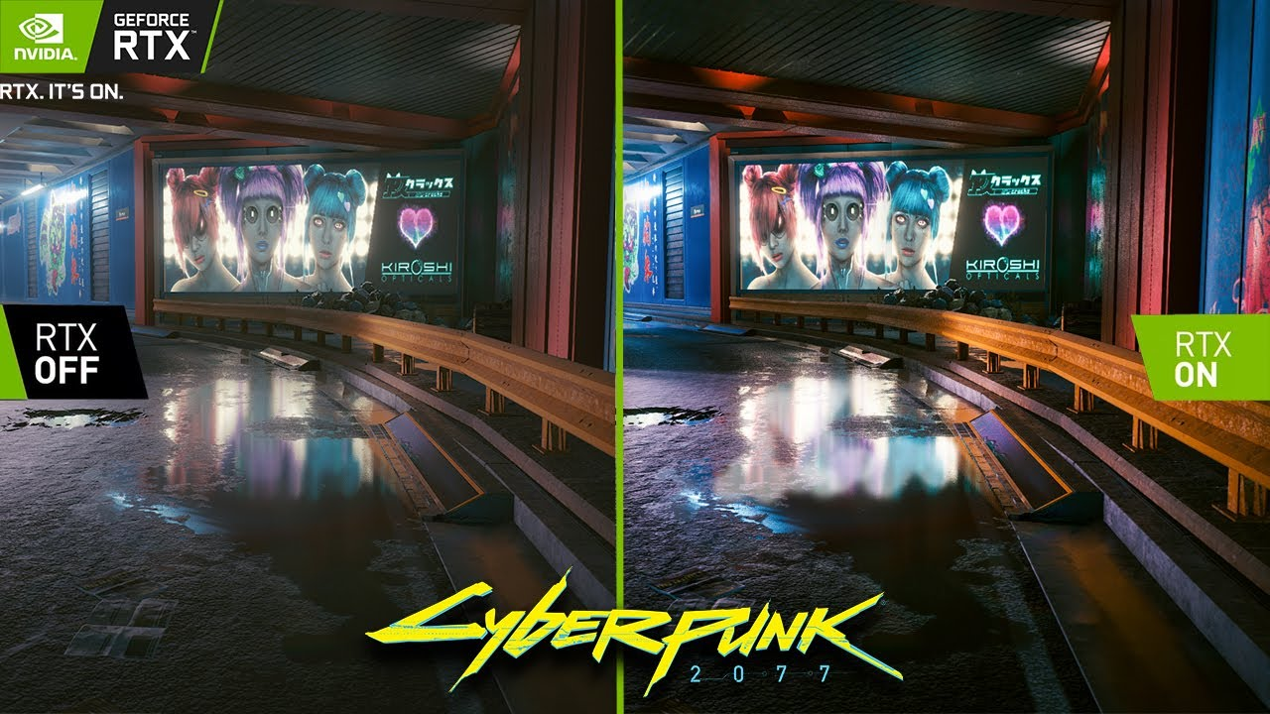

On the left side of the image we can find the scene rendered with the raster algorithm and on the right side the same scene rendered with a hybrid pipeline. We can observe the improved quality of the reflections on the puddles and how the light effects are more realistic and clear.

## Non-Euclidean geometry in Games

There are extensive examples of games that implemented in some way or another non-Euclidian spaces (*Portal, Antichamber, The Stanley Parable, Split Gate*...), but most of them opted to fake the effect, severely limiting its possibilities.

I will use the video game *Portal* to explain how non-Euclidean spaces are faked. In this game the player can create portals that connect spaces together and they can traverse this connection to arrive to the other connected space.

**Figure 11 Portal example**

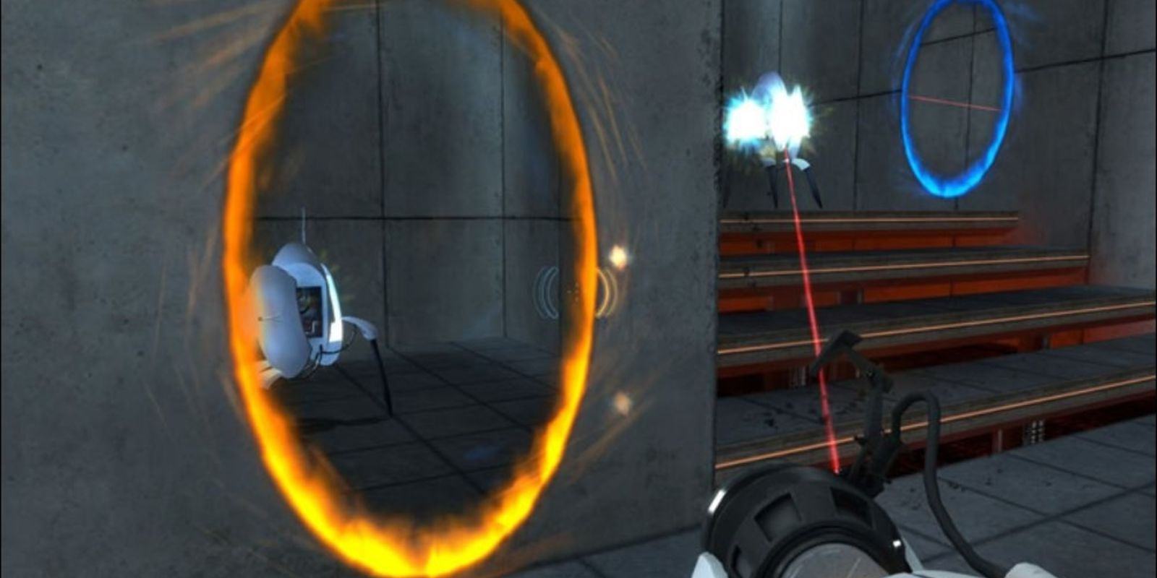

*Note:* Here we can observe that the blue portal connects the space with the orange one.

In this case the position of the orange portal is located a texture and a collider, this texture is the render target of a camera situated behind the blue portal, which matches the field of view of the player, creating the illusion that the space is connected, the collider is used to instantly move the player to the blue portal position, fast enough so that the player does not notice it (DigiDigger, 2017).

There is a game still in development that accomplished rendering hyperbolic geometry (type of non-Euclidean geometry not covered in this research) in real time, named *Hyperbolica*.

## Non-Euclidean rendering engines

During the investigation process, 3 different non-Euclidean real-time rendering engines stood out, each one with different features and capabilities, but none of them had the tools needed to modify the scene and aberrations in execution through an inspector or a gizmo. It is also worth mentioning that only one of them was able to render meshes, but with a high limitation in number.

### Visualization of Non-Euclidean Spaces using Ray Tracing (2019)

Able to render different aberrations with simple geometry placed on the scene, but as the name implies, it is not an engine with the different tools needed to load scenes, meshes, place the objects and edit the aberrations during the execution of the program.

For more information: <https://www.researchgate.net/publication/337472155_Visualization_of_Non-Euclidean_Spaces_using_Ray_Tracing>

**Figure 12 Visualization of Non-Euclidean Spaces using Ray Tracing caption**

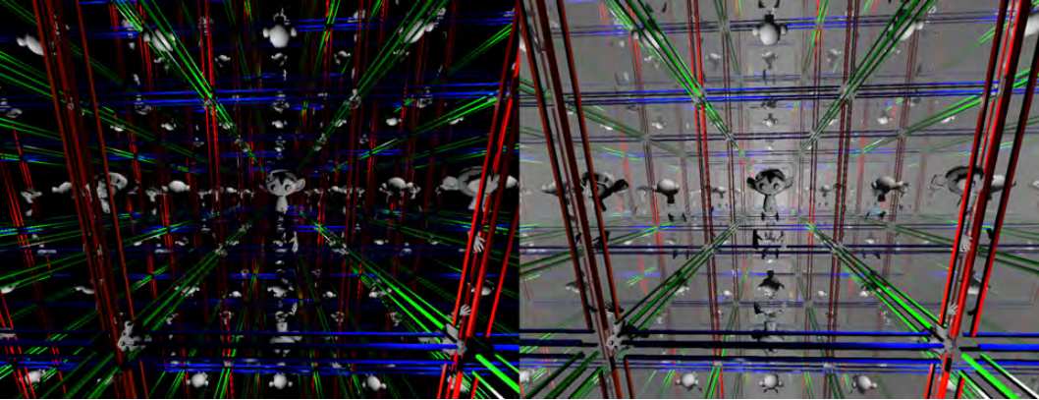

### Real-Time non-Euclidean Ray-tracer Demo

Able to render aberrations and portals with different shapes, but has optimization problems (fps drops when going through a portal or aberration) and is unable to render meshes and textures. All the objects are made by stating shape variables and setting the object’s position, which limits the possible objects to simple shapes. It is also worth mentioning that the project doesn’t have the tools to modify the objects and aberrations during the execution, all of them are hardcoded into the scene (Varun R., 2013).

For more information:

https://youtu.be/YvU-srHhQxw

**Figure 13 Real-Time non-Euclidean Ray-tracer Demo caption**

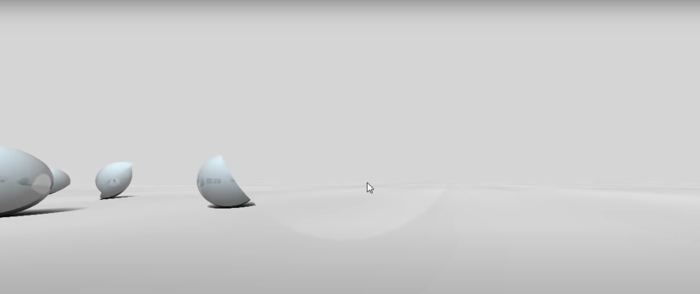

### Non-Euclidean GPU Ray Tracing Test

Able to render aberrations that change the direction of the rays and modify the speed of the camera accordingly, thus elongating and compressing space. Can handle multiple objects with different textures, but it cannot render geometry since the engine is based on voxels (box units that form the scene) thus limiting the objects to simple shapes (CNLohr, 2011).

For more information:

https://youtu.be/0pmSPlYHxoY

https://youtu.be/tl40xidKF-4

**Figure 14 CNLohr engine caption**

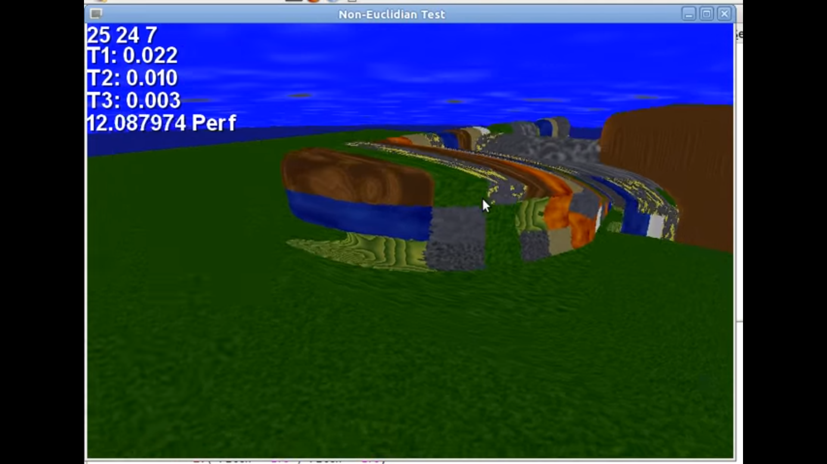

## Contribution

The contribution of the project to the current state of the art will be in the usability department. As stated before, currently there is no known scene editor that supports non-Euclidean spaces, will allow de users to edit scenes with non-Euclidean aberrations in real-time through the engine editor tools and gizmos in an attempt to showcase the medium possibilities to a major public and allow them to experiment and prototype ideas or concepts.

The engine will not be able to render big and complex scenes with lots of objects, but will allow the user to render and import meshes. This will give freedom to the user to test non-Euclidean spaces in a variety of scenarios.

This project will also be the first to showcase aberration space deformation in a render engine capable of processing meshes, note that this is not possible with the CNLohr render engine because it works on a voxel render engine (the smallest unit in the scene is a cube).

# Project development

To have a better understanding of the process of developing this project I will first define the requirements, design, implementation and verification process of each feature in chronological order.

The verification paragraph will contain the verification and verification 2 steps.

## Development: Real-time GPU ray tracing algorithm with meshes

### Requirements

As stated before, this rendering method will allow us to deform the way elements are visualized with a level of freedom that cannot be archived using the raster rendering technique. Mesh rendering will be needed to create simple scenes that will showcase the engine capabilities. A lot of optimization investigation will be needed in order to archive a stable frame rate that will allow users to edit the scene and see the aberrations effects in real-time.

### Design

**Compute shaders:** To start the implementation of the ray tracing algorithm, first we need to decide on how will we calculate the collisions with the camera rays with the scene. This is a simple calculation that will be repeated 640.000 times each frame (one ray for each pixel in an 800x800 camera).

This kind of scale problem can be subsided by using the GPU to do this calculations (compute shaders) in our case we will be using OpenGL version 4.3.

CUDA and OpenCL (parallel GPU computing platforms) were quickly discarded due to the lack of experience and the need to rewrite a major part of the base engine in order to implement them which would delay the start of the project. It should be noted that CUDA and OpenCL would provide a faster execution time thanks to the access to low level hardware administration.

**Ray tracing algorithm:** The implementation is very straightforward as it makes use of basic math vector calculations in order to find the closest collision point in a triangle in a given direction, the Möller-Trumbore algorithm will be the one implemented since it is widelly used due to its polivalence.

**Passing data to the GPU:** Passing data to the GPU in the fastest way possible will be a determining factor to reach real-time frame rate. The transform data (view camera matrix, mesh world matrices, …) will be sent as uniforms (easy to set and flexible, but very slow) and the scene vertex data (vertices, indices, texture coords, …) will be sent as textures to the GPU.

Uniform buffers are faster than uniform variables at the cost of using more memory, but the method could not be implemented due to time constrains. It consists in writing all the uniform data directlly in the GPU memory and interpret it in the shader.

### Implementation

**Compute shaders:** Firstly, I created the option to select the rendering method (raster / ray tracing) in the editor, then prepared the output texture for the compute shader, and passed it to the ImGui window so that it could be displayed.

Then the shader importer module was modified so that it could load compute shaders and allow shaders without vertex and fragment components. I wrote a simple compute shader that painted each pixel pink and checked that it was loaded correctly without errors.

Lastly, the compute shader was set up and dispatched in the ray tracing render function, and got the following output.

**Figure 15 Compute shader output**

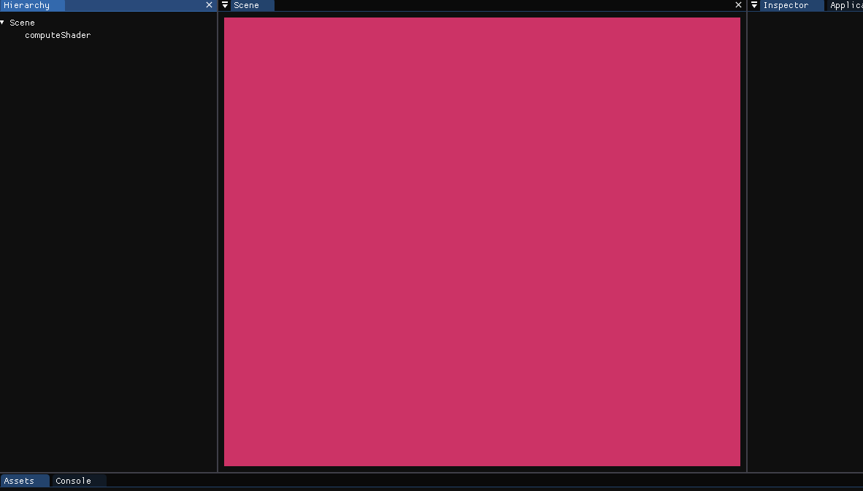

This simple output assures us that the compute shader is loaded correctly, it’s output is correct and the output texture is being handled properly.

**Ray tracing algorithm:** Various steps were done in order to test various aspects of the code (camera ray’s direction, distance test, compilation speed…).

One ray would be calculated for each pass of the compute shader and this ray would paint one pixel of the texture. The direction of the ray would be determined by the camera position and the pixel of the texture in the OpenGL coordinate system. Since the texture pixel coordinates range from 0 to pixel-size, we need to transform it to a range between -1 and 1. This would allow us to have a perspective camera which will help with depth and distance perception.

The first shape that was tested was a sphere, a simple geometric shape that is fast to implement.

**Figure 16 Sphere ray tracing test**

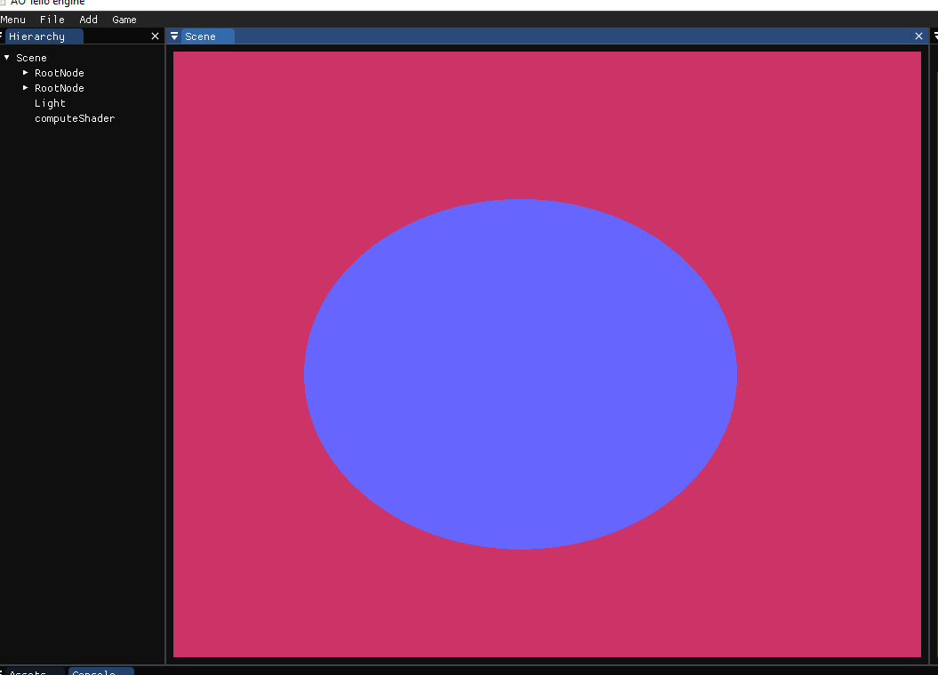

The results seem satisfactory, but once the camera was moved sideways, the sphere would deform, indicating that something was not being calculated correctly.

**Figure 17 Sphere deformation**

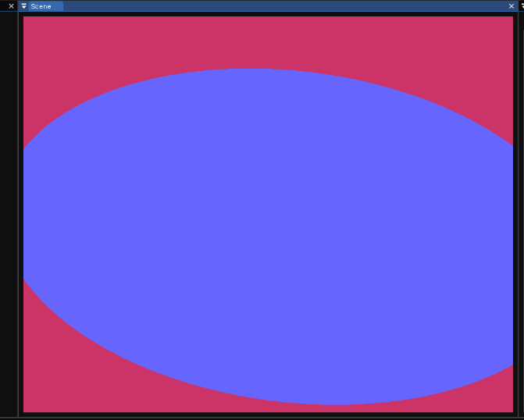

The problem was solved by checking if the point of collision is behind the camera, and calculating the camera rays using the camera’s FOV and aspect ratio.

The next shape that was tested was a triangle, which is the basic shape that constructs meshes. The first implementation used an analytical solution to compute if the ray intersected with the triangle but this implementation is way too slow to be used alongside meshes (take into account that the difference with one triangle is negligible, but once we have a mere 200 triangles in the scene which we will have to test collisions with every triangle for every ray we cast) and was replaced by the Möller-Trumbore algorithm.

**Figure 18 Triangle ray tracing test**

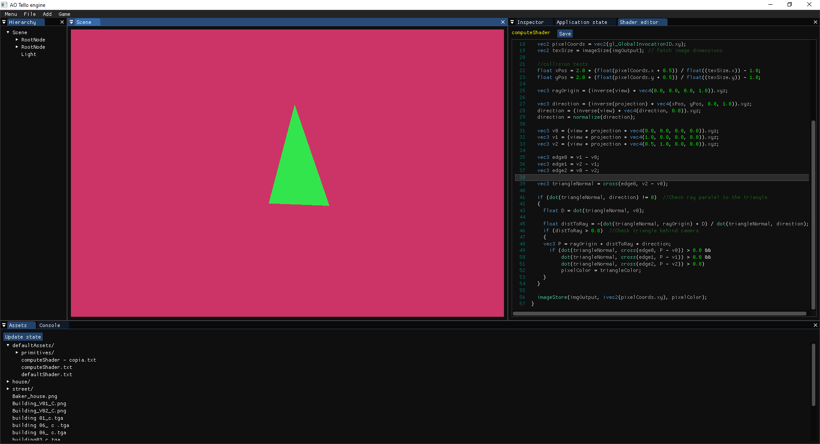

**Passing data to the GPU:** As stated before, we will need to codify the mesh vertex data as various textures and indicate OpenGL to not normalize their values.

A texture will be used to store all the vertex values of all the meshes in the scene, each pixel of this texture will represent a vertex position, and its RGB values will represent the xyz coordinates.

Another texture will hold the UV values of the meshes, each pixel will represent a 2d point (uv), and its RG values will represent the x and y coordinates.

Another texture will be used to store the indices of all the meshes in the scene, each pixel will represent a triangle, and its rgb values will represent an iterator to the vertex texture.

The mesh data (world transform, vertex offset, vertex count, color and texture) will be sent using uniforms.

Once the data was correctly sent to the GPU, small adaptations were done in the shader code so that it could translate the geometry textures and find the nearest collision point to the camera position.

**Figure 19 Cube mesh error**

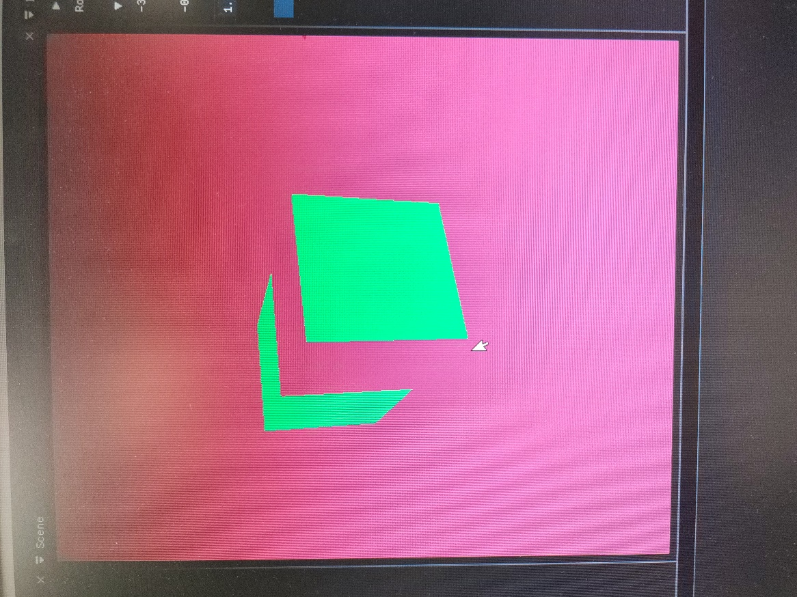

An error in the calculation of vertex collisions caused certain vertex of the mesh to be displaced in the Z direction, the problem was caused because of a sign error in a mathematic calculation.

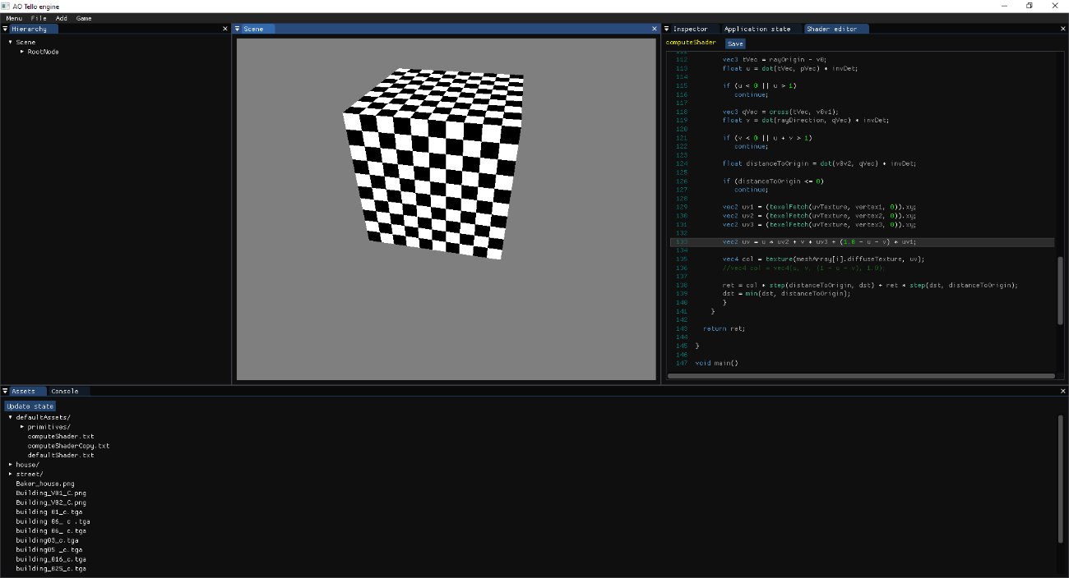**Figure 20 Multiple cube meshes**

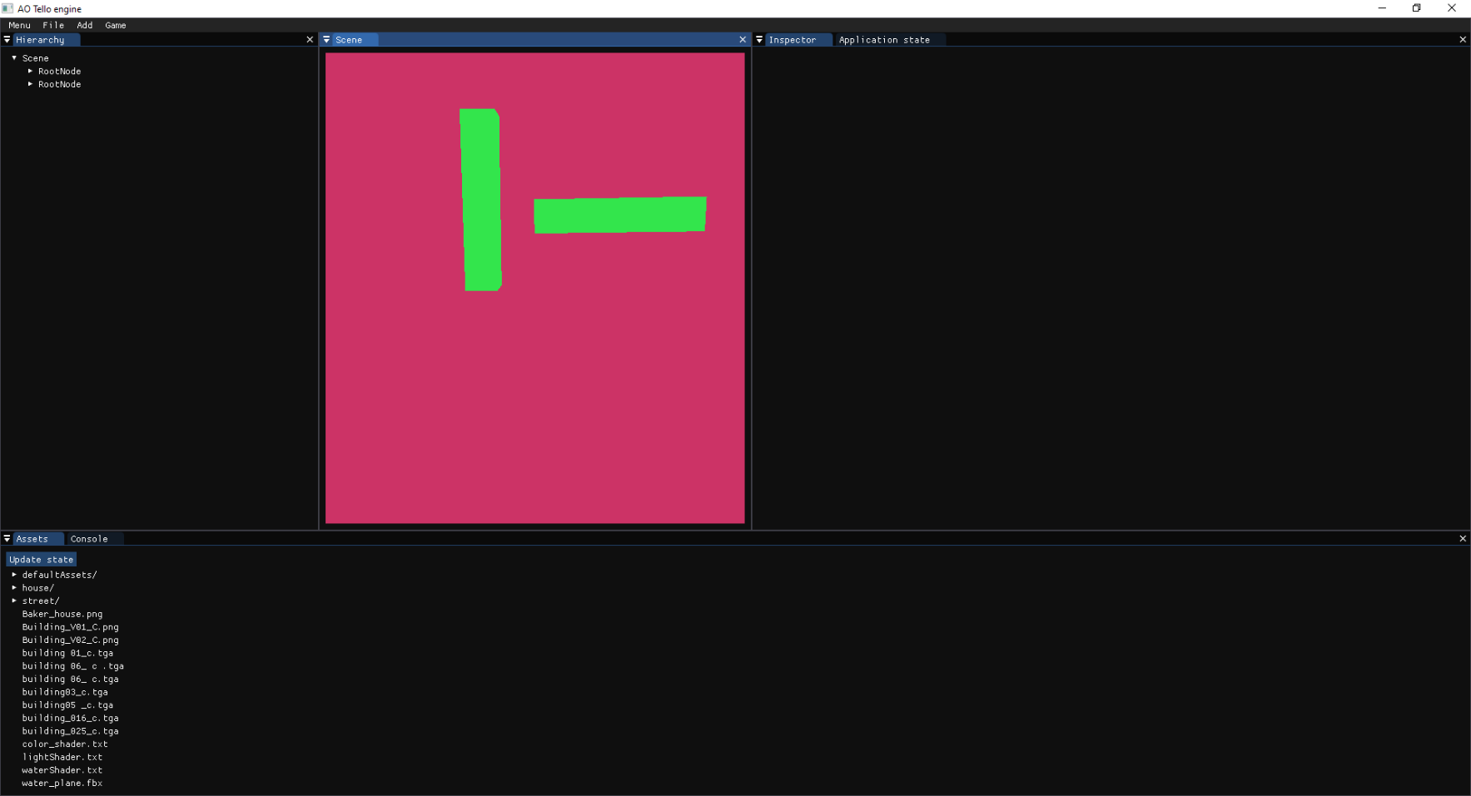

In the left image we can see two cube meshes that have been moved, rotated, and scaled in different axis. The right image shows a cube with the default texture.

### Cleaning & Optimization

As stated before, each ray is testing all the triangles in the scene for collision, which is very inefficient. To solve this issue AABB’s were implemented with the objective of avoiding unnecessary triangle tests.

A system to automatically add an AABB box to each mesh was already implemented (used in the raster render), so the only thing needed was to send the AABB box of each mesh to the GPU using uniform variables and to create a method that checks ray-AABB box intersections.

### Validation

At this point, it was possible to add multiple meshes to the scene which can be translated, rotated and scaled using the inspector, and have a default texture that helps the user judge depth and distances. The user is also able to import meshes in .obj format and change its base color using a color picker in the inspector.

**Figure 21 Mesh color picker**

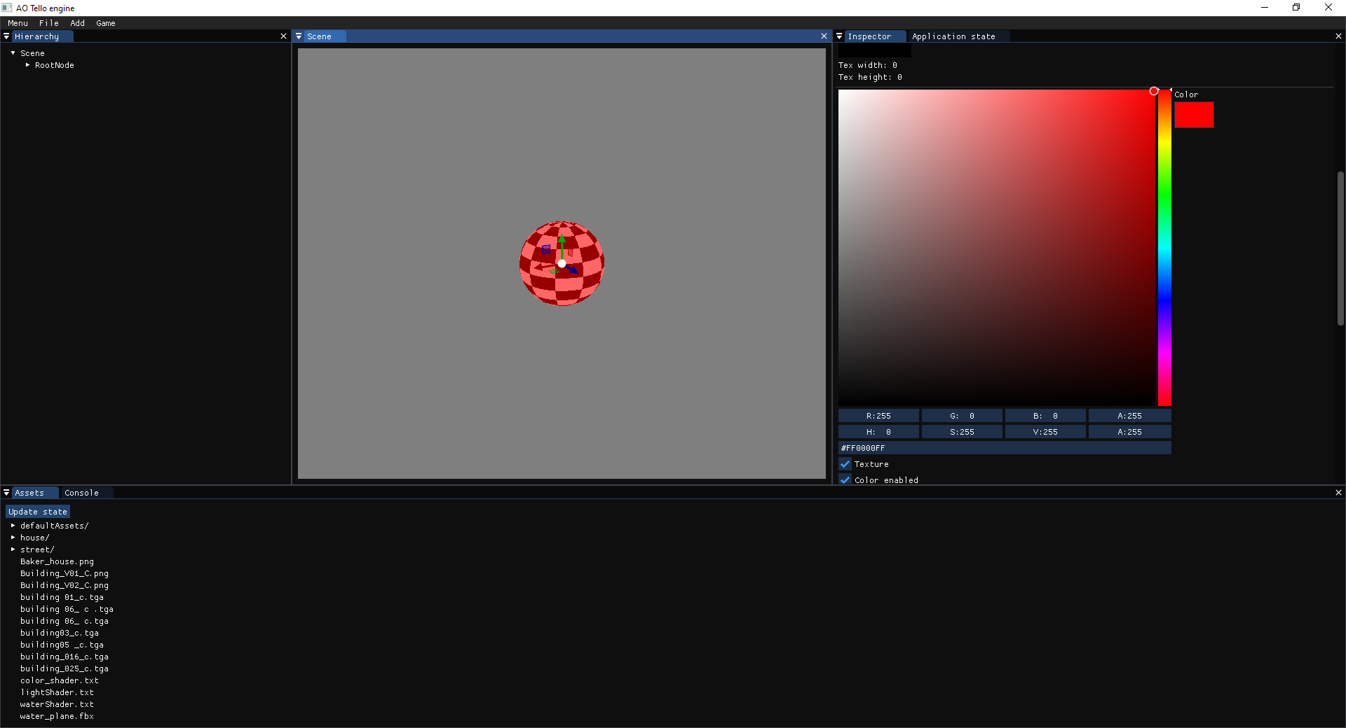

The engine is currently working at around 150 – 200 FPS in scenes with 10 cubes in a RTX 1050Ti GPU’s. And at around 350 – 500 FPS in the same scene in a RTX 3060Ti.

**Figure 22 House mesh**

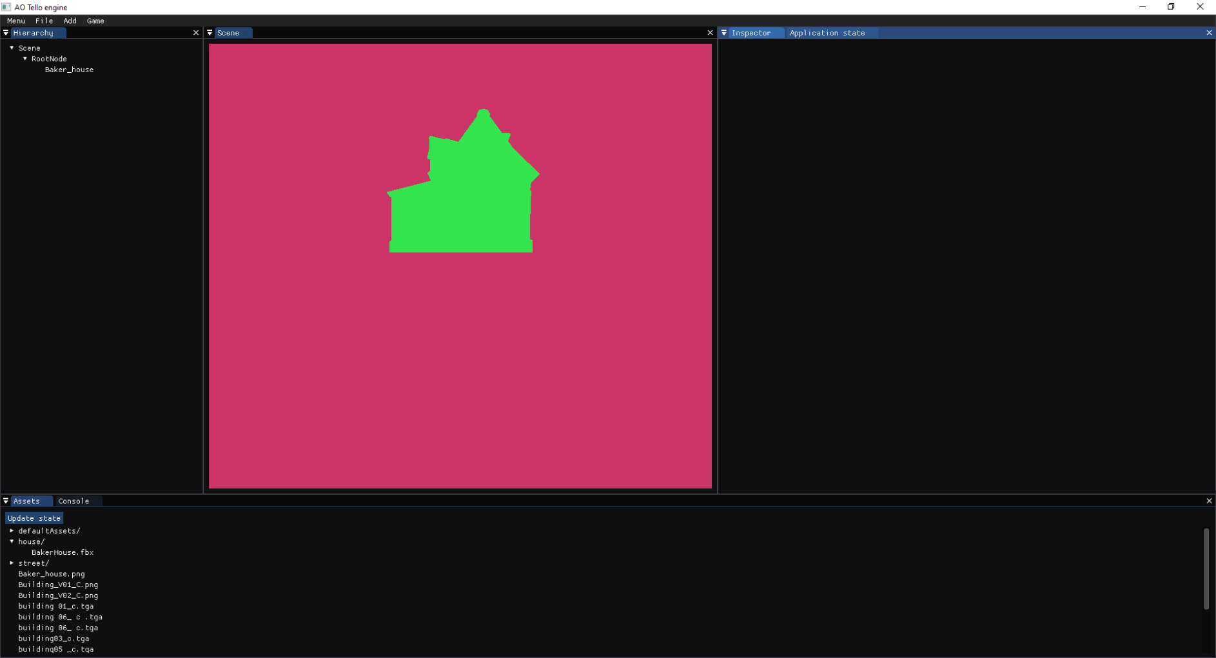

A scene with a house mesh (5500 vertices) would run at around 60 FPS in a RTX 3060 Ti which was estimated as a valid result since the rendering method was expected to be slow, but this limit will allow to create scenes with shapes more complex than simple cubes.

## Development: Aberrations edition and previsualization tools

### Requirements

In order to allow users to experiment with non-Euclidean design experiences, a set of aberration edition tools and a method to visualize their location and area of effect will be needed, it will also allow us to test edge cases once we start deforming the rays.

### Design

**Create aberration component class:** Create a class with all the variables and base functionality needed: Save and load, initialize, update, mesh (the shape of the aberration), deformation direction, activate / deactivate debug draw….

**Figure 23 Component aberration class UML**

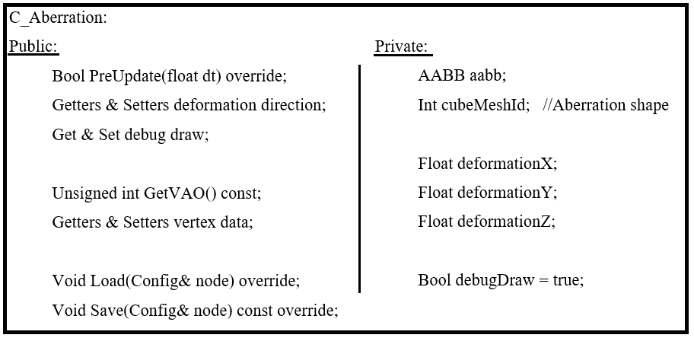

**Add editor functionality:** A button to add a scene node with an aberration component will be placed in the *Add* drop down menu and the inspector will display and allow the user to modify the aberration data. Thanks to the ImGUI library these changes can be added very quickly.

**Aberration previsualization:** It is not possible to draw a mesh outline using the compute shader, so another render pass is needed in order to draw the aberration previsualization.

Directly drawing the outline of the shape using the raster rendering method would cause that the outline would be always completely drawn independently of the other meshes which would reduce the usability of the level editor.

To solve the depth problem, we use the raster render to render all the meshes of the scene in a completely transparent color that will generate depth buffer data, and then draw the aberration outlines. Since OpenGL does not check if the object is transparent before discarding it in the depth test, the outline will be drawn correctly when a mesh is placed in front of it.

### Implementation

**Create aberration component class:** Created as a child of the component class, it has an ID to the mesh resource that represents its shape (cube), this method can be easily changed in order to allow the user to select the shape of the aberration, but was not implemented due to time constrains and the inability to ensure FPS stability (aberration shape vertex count could impact the frame-rate more than the meshes).

The aberration shape will be affected by the scene node transformation the same way a mesh is affected, allowing to move, rotate and scale it using gizmos or changing these values in the inspector.

**Add editor functionality:** Using the ImGUI functionality, the button to add a scene node with an aberration component was added, and a new collapsing header that displays and allows the edition of the aberration deformation direction and a checkbox to activate or deactivate the debug draw.

**Figure 24 Aberration editor**

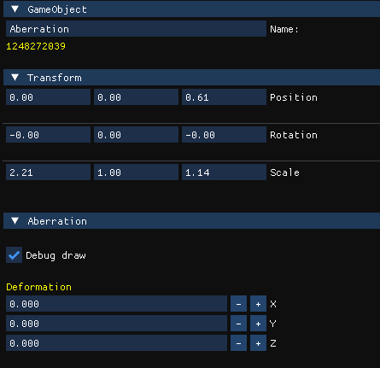

Here we can observe the inspector displaying the data of the game object that contains the aberration, it contains:

* Input text component to rename the game object
* 3 drag float components that allow to modify the x, y and z position.
* 3 drag float components that allow to modify the x, y and z rotation (in degrees).
* 3 drag float components that allow to modify the x, y and z scale.
* Checkbox to enable/disable debug draw.
* 3 input float components that allow to modify the x, y and z ray deformation.

**Aberration previsualization:** After the compute shader render pass is finished, the same texture is set as the target of a raster rendering pass in which the depth buffer is activated where we render all the meshes of the scene with a shader that makes them transparent and then the aberrations are drawn using the OpenGL line polygon model.

**Figure 25 Aberration previsualization**

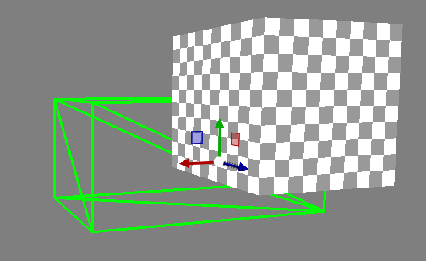

The area affected by an aberration is represented by the green lines and we can appreciate that the depth perception is working properly since the upper-right corner of the aberration is being occluded by the object in front of it.

### Cleaning & Optimization

Since the aberration previsualization is using the raster rendering method, known for being the fastest rendering method, and the shaders only calculate the positions of the vertices and directly paint the texture with the set colors (transparent for meshes and green for aberrations) the process is extremely fast and the performance has not been affected, even when using meshes of 5.500 polygons.

This result was expected because nowadays raster rendering engines are able to render scenes with 5 million polygons in real-time (note that each of the meshes of the scenes have around 3 to 6 textures, light, reflection and shadow calculations) so it is not unusual that it has no problems rendering small scenes with a low polygon count.

### Validation

At this point the engine has the features needed to create, save and load aberrations in the scene. These aberrations can be moved, rotated and scaled using the gizmos, and their information can be set through the inspector.

The previsualization method of the aberrations is working as expected and hasn’t affected the performance of the application.

Furthermore, the code is ready to work with meshes since the only functionality needed is to be able to change the mesh resource that the aberration is using. Despite being a feature out of the scope of the project it is a possible future expansion.

## Development: Aberration ray deformation and collision detection

### Requirements

Functionality that will displace and change the direction of the camera rays once they interact with an aberration, allowing us to create the illusion that the space is being expanded or compressed.

### Design

**Pass aberration data to the GPU:** The aberration data will be treated similarly to a mesh, the aberration mesh data will be codified in the mesh textures (vertex and index textures) and the aberration data (transform, AABB info, vertex offset and deformation direction) will be send using a uniform variable.

**Find nearest ray collision:** Unfortunately, it will be needed to first test ray-mesh collisions and then test ray-aberration collisions and, after comparing the distance between the two collided points, the closest one will be the collision point.

In case that the ray intersects with an aberration a new ray shall be cast from the collision point, so we will need to calculate this point using the distance to the collision and the ray direction.

**Deform the rays that collided with an aberration:** Once the rays collide with the aberration, we will cast another one from the collided point with the deformed direction.

Even though there is no information about how the rays should be deformed, the question stands: *how are the rays deformed?* There are a variety of approaches that could be taken and “be correct” but that is not the focus of this investigation, which lies in finding how can the rays be deformed in a way that will create the illusion that the space and the objects inside of it are elongated or compressed.

This led to the conclusion that a variety of methods should be implemented, documented and tested in order to select the most suitable to accomplish our desired effect.

* Once the ray collides with the aberration, cast the ray from the collision point, add the deformation values directly to the ray direction and then normalize the vector.
* Once the ray collides with the aberration, cast a ray from the collision point and compute a radial interpolation that makes the rays direction to get closer or further away from the center ray.
* When the camera is inside the aberration and the ray exits the aberration:
  + Deform the ray in the same direction.
  + Apply to the ray the inverted deformation.
  + Set the original ray direction previous to any deformation.

### Implementation

**Pass aberration data to the GPU:** Will proceed with a similar approach as the one used in the meshes, the vertex and index data will be codified in the same textures as the meshes data, and their transform, vertex offset, triangle count and deformation direction will be sent using uniform variables.

**Find nearest ray collision:** The method used to test ray-mesh collisions was adapted support aberration collisions.

Once the nearest collisions of each type are calculated, we will use the *step* GLSL function to multiply by 0 the values of the farthest collision. Calculating both cases and selecting the correct one is a common practice in GPU programming since the use of if statements would cause branching delays which are more performance demanding.

To test that the nearest collision was being calculated correctly, if the closest collision was the aberration the output was set to be yellow.

**Figure 26 Aberration and mesh collision test**

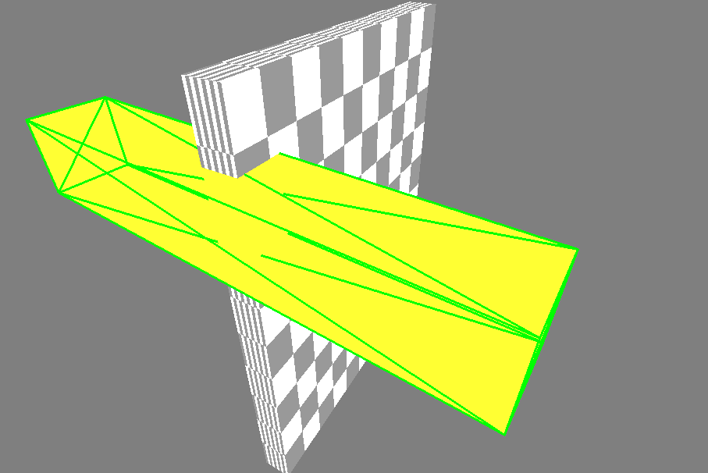

In this image we can observe that the collision detection is working properly, since the aberration (yellow) is completely enclosed by its AABB box and is being painted in front of the mesh, but the mesh is being drawn on top when it intersects with the aberration.

**Deform the rays that collided with an aberration:** As stated before, different approaches were tested in order to choose the one that produced the desired results and visual effects.

***The first approach*** was to, once the rays enter the aberration, the aberration deformation would be added to the ray direction.

**Figure 27 Unidirectional aberration**

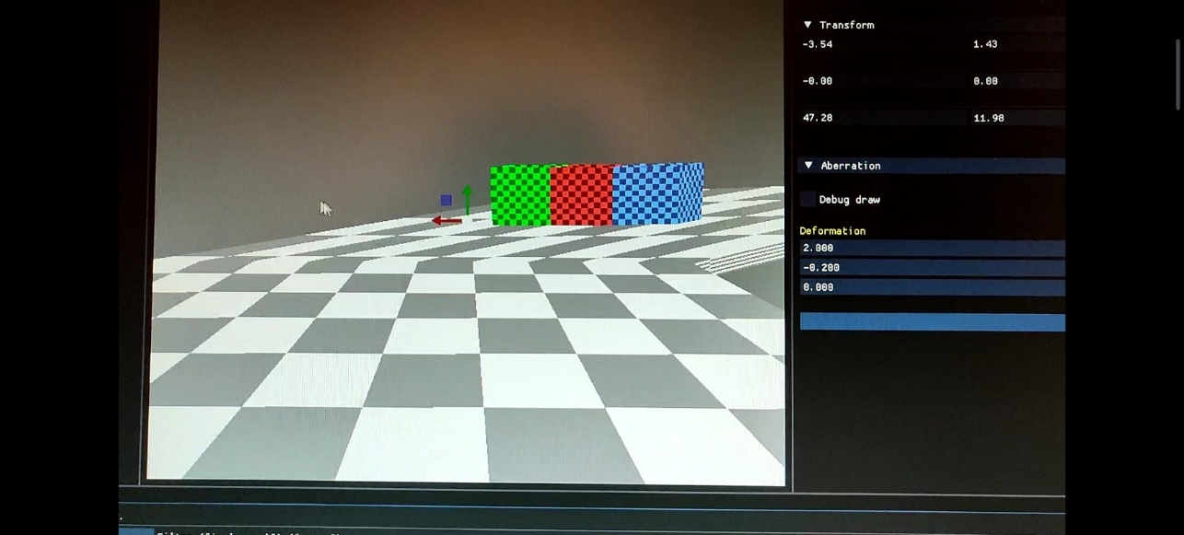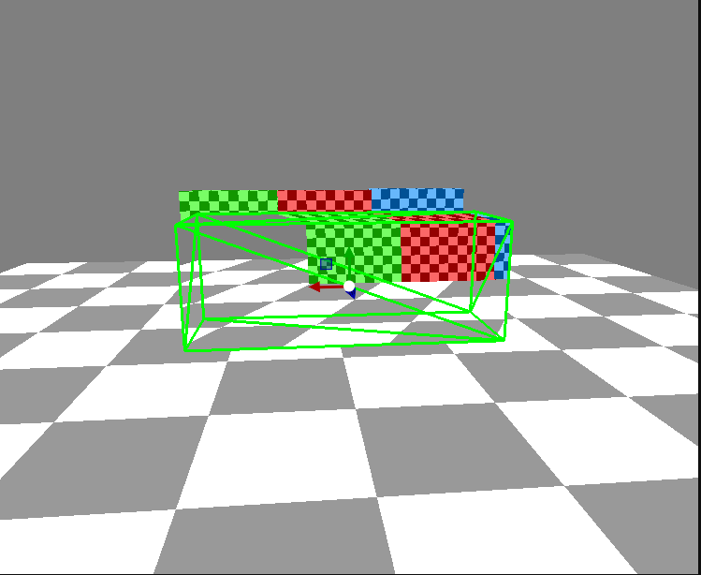

In this image we can appreciate how the aberration is unidirectionally deforming the space in the x direction, making the illusion that the elements of the scene are moved to the right.

Even though this approach does not allow the user to compress or expand the space, it creates an interesting effect that should be considered as possible addition to the application.

***The second approach*** consisted on deforming the rays outwards or inwards relatively to the distance to the central camera ray.

**Figure 28 Ray deformation diagram**

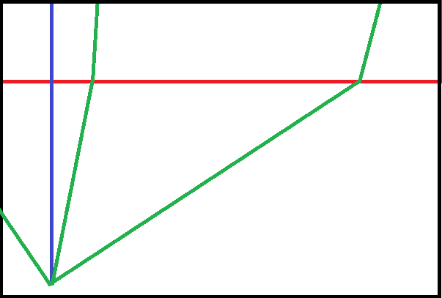

In the previous image we can see some camera rays (green) and the central camera ray (blue), which collide with an aberration (red) that is compressing the space. The deformation will not affect the central ray, but the deformation will increase the further away the ray is relatively to the central ray.

**Figure 29 Ray radial deformation**

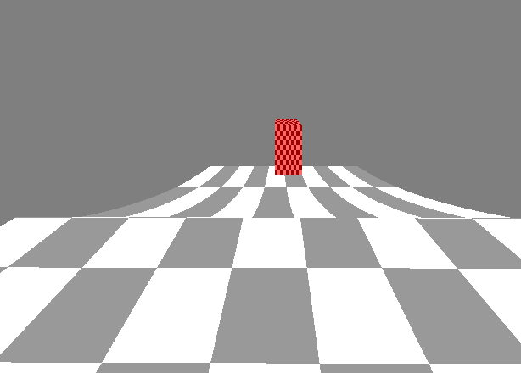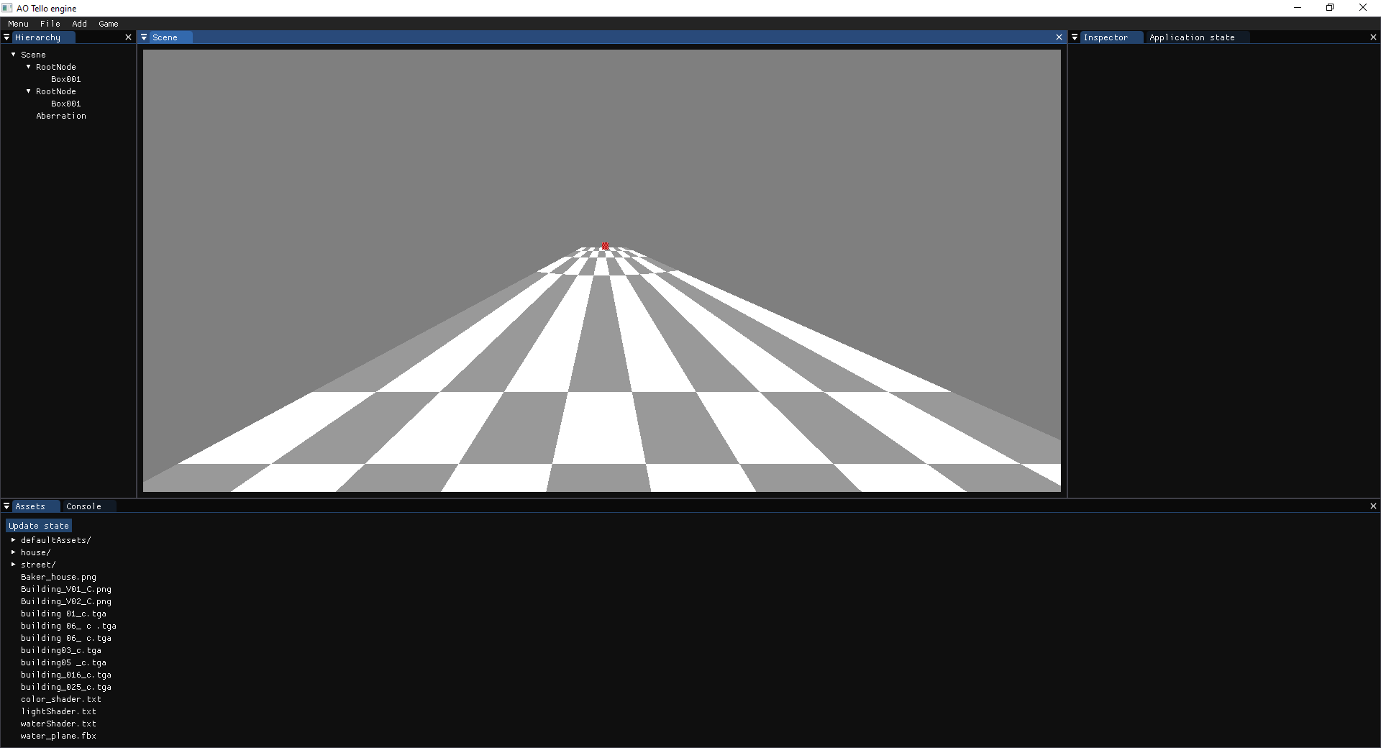

In the left image we can observe an aberration compressing the space in the x axis, making the cube look slim, on the right image we can appreciate the same scene but the aberration is elongating the space in the z axis, which makes the cube look really far away.

This method allows to create the effect of compressing and expanding the space with a great visual fidelity and interest and allows for a lot of flexibility when creating and editing a scene, but this flexibility causes a mirroring problem.

**Figure 30 Mirror problem example**

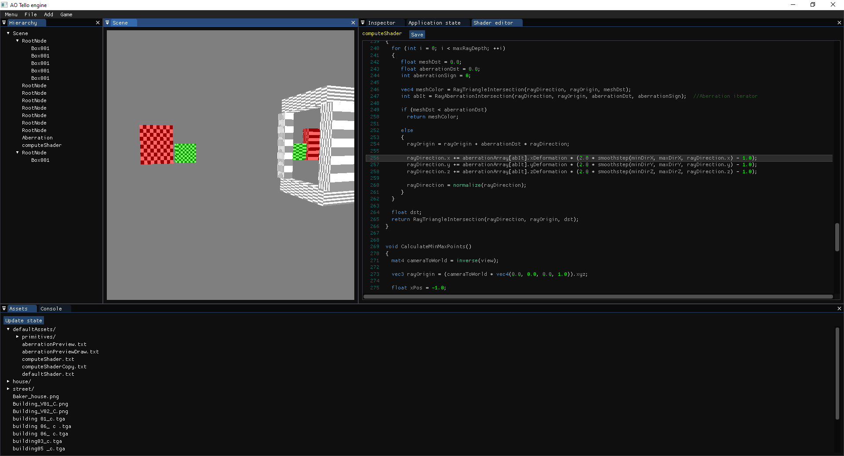

In this image we can observe that there is an aberration at the entrance of a white tunnel, and it has a deformation value big enough to make some of the rays that collide with it bounce out the aberration creating a mirror effect. Solving this effect involves setting a limit to the deformation of the rays, severely limiting the possibilities of the tool, and, since it is possible to hide this problem using the layout of the scene (limiting the angles from which the aberration can be seen, use the same colors for the room and the tunnel so that the mirror effect is not noticeable…), it was decided to not limit the deformation of the rays.

***Inside-outside aberration deformation:*** When the ray exits the aberration it should be deformed in a way that reinforces the illusion of the deformed space.

Firstly, the ray-aberration intersection method was modified in order to check if the ray was entering or exiting the aberration, which led to 3 approaches:

When the ray exits the aberration, apply the same deformation again.

**Figure 31 Aberration-ray exit test 1**

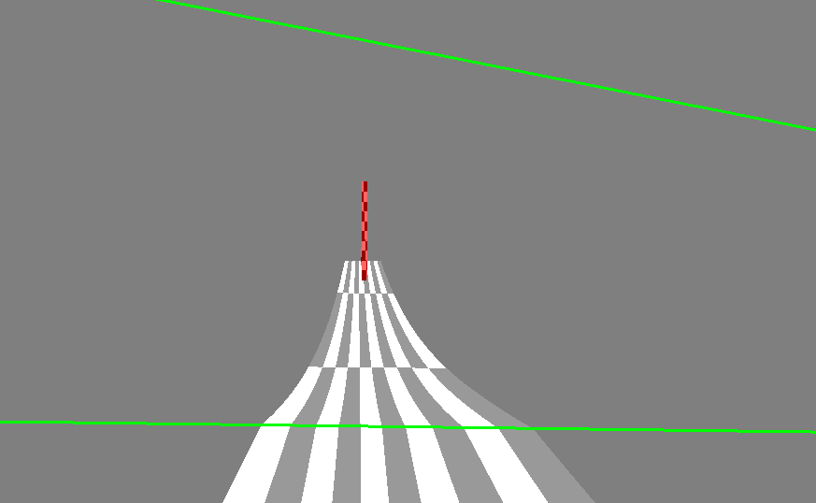

This method causes a lot of confusion since the objects change their location once the user exits the aberration, creating the illusion that the user was teleported instead of a unified space with different densities.

When the ray exits the aberration, apply the inverted deformation.

**Figure 32 Aberration-ray exit test 2**

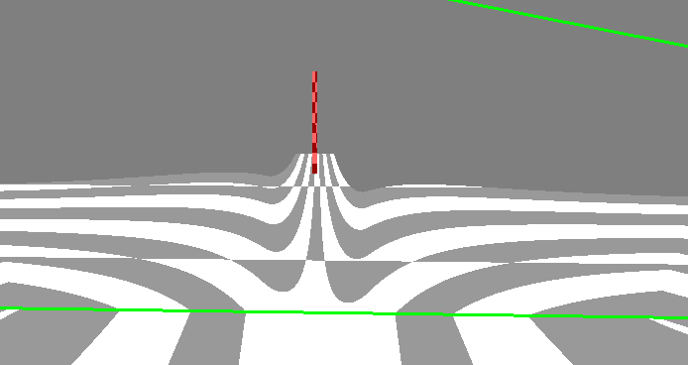

This led to objects changing their position once the player exited the aberration, thus a sudden change. Apart from some undesired visual artifacts.

When the ray exits the aberration, set the ray direction as the original ray direction.

**Figure 33 Aberration-ray exit test 3**

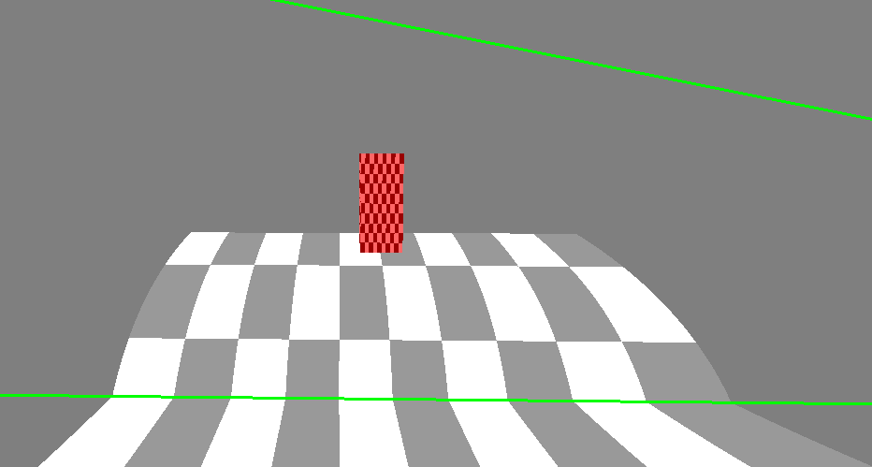

This makes the aberration effect diminish as the camera gets closer to the exit of the aberration, which creates a smooth transition when entering and exiting an aberration. The deformation remains consistent when entering the aberration from the outside.

This is the method selected for the application.

### Cleaning & Optimization

The shader code was reorganized in order to have a cleaner code structure, and if statements were removed in order to reduce GPU branching.

Despite the efforts, the overall performance is halved when the rays traverse an aberration this was expected because when a ray collides with an aberration, another ray is casted into the scene, which has to be tested against all the geometry of the scene again.

### Validation

The engine is able to visually deform the space in a believable and consistent way using aberrations, which can be edited in real-time through the inspector.

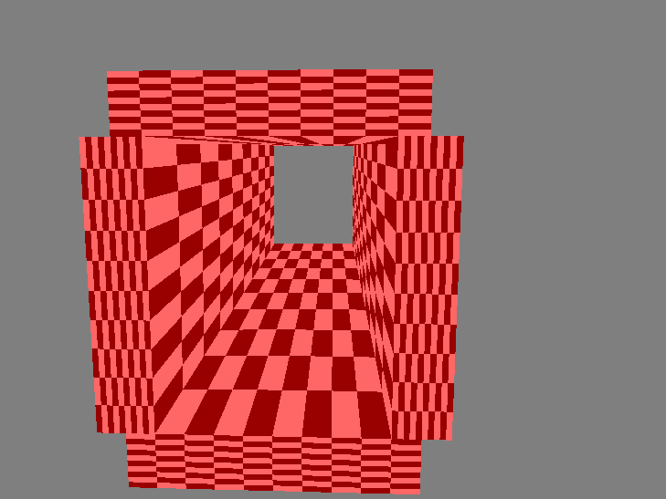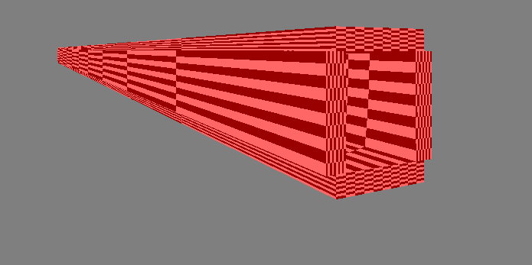**Figure 34 Z deformation tunnel**

In these images we can observe the same tunnel which has an aberration inside of it that compresses the space in the Z direction, making it shorter in the inside than it is in the outside.

## Development: Camera-aberration interaction

Currently when the camera is inside the aberration the rays are not deformed until they exit. A system to detect when the camera is inside an aberration will be needed to solve this issue, and this system will also be used to modify the speed the camera uses to move in order to change its movement speed depending how the space is deformed.

### Requirements

Reduce or increase the camera movement speed to create the illusion that the space is being deformed and apply the deformation to the rays if the camera is inside an aberration.

### Design

**Detect camera-aberration collision:** To test if the camera is inside the aberration, we can calculate the inverse transform of the aberration and use it to calculate the position of the camera in aberration-space that, since we are using box shaped aberrations, allows us to do an inside–outside AABB test which is way cheaper than doing an inside – outside test for a non-axis-aligned box.

**Initial ray deformation when inside aberration:** If camera is inside the aberration, send the aberration’s array data to the GPU and deform the rays before doing their intersection tests.

**Camera movement affected by aberration:** Camera movement shall be reworked to use a vector which will be affected by the aberration in the same way the camera rays are affected.

For example, a deformation on the X axis with a value of 1 represents a decrease of 100% of the space in the X direction, which translates to doubling the speed of the camera.

### Implementation

**Detect camera-aberration collision:** In the camera module of the engine, a new method was implemented to check when the camera was inside an aberration. To test this case, the camera position was transformed into mesh coordinates and then tested if it was inside the AABB box formed by the mesh.

To test if the method was working properly a log was printed on the application console each frame that the camera was inside the aberration.

**Initial ray deformation when inside aberration:** The method where we test if the camera is inside the aberration now saves the position in the aberration array that corresponds to the aberration that is containing the camera (the value will be -1 if the camera is not inside an aberration). This position will be sent to the GPU using a uniform variable.

In case that the iterator value is different than -1, the shader will deform the rays using the data of the aberration that corresponds with the iterator, and then do the mesh and aberration collision tests.

An if statement will be needed in order to indicate if the camera is inside an aberration or not. This if statement will have the same behavior for all the pixels of the texture so it will not cause branching.

**Camera movement affected by aberration:** If the camera is inside an aberration, the module will store its deformation values.

The camera movement code was reworked to calculate the direction it should move towards, and multiply that direction by a scalar that represented the camera speed (taking into account the delta time between frames).

To deform the speed of the camera, each component of the camera movement direction will be multiplied by the percentage of the deformation.

### Cleaning & Optimization

The old camera movement code was removed and all the camera logic was set to use the delta time between frames so that the camera speed is frame-independent.

Options to edit the camera movement values through the inspector were added.

The application performance has not been affected by the addition of these features thus optimization of this code was estimated unnecessary.

### Validation

The camera correctly identifies if it is inside an aberration and the camera rays are deformed accordingly by it, once the ray exits the aberration it returns to its original state creating a transition when entering and exiting it. Lastly the camera movement is affected by the aberration it is traversing enhancing the illusion that the space is being deformed accordingly.

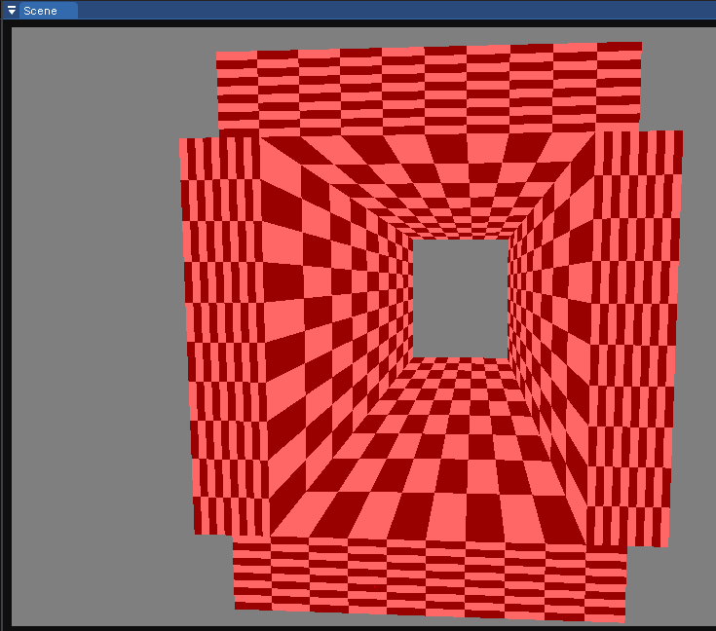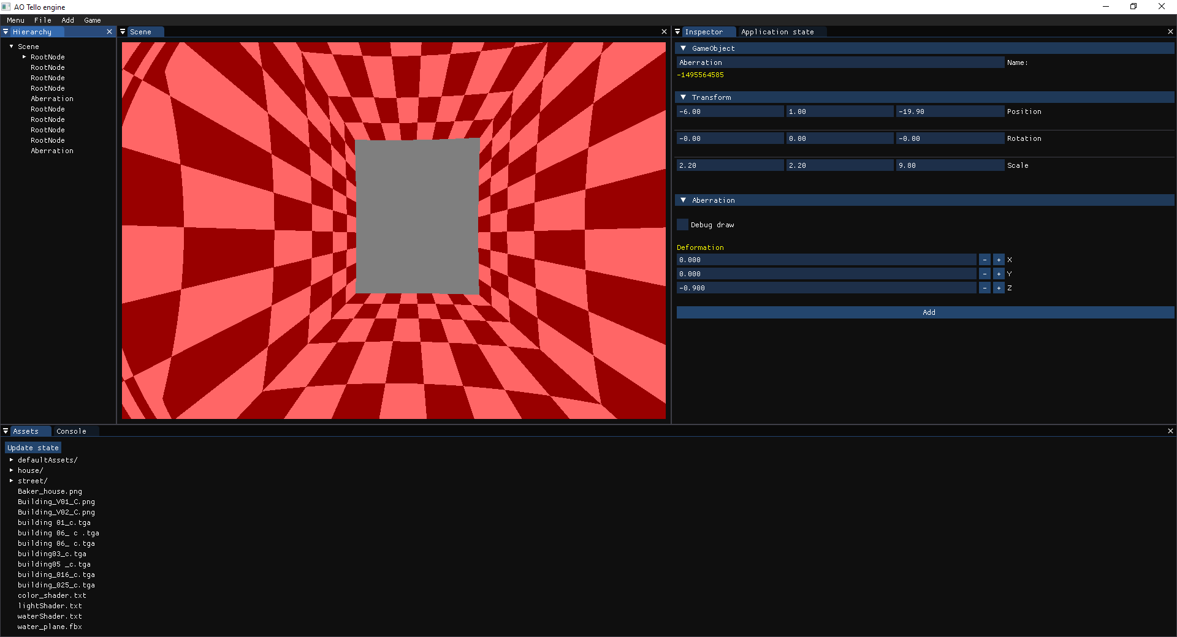**Figure 35 Camera inside aberration demo**

In this image the scene is composed by a tunnel that contains an aberration inside that compresses the space and we can observe how the camera is correctly deforming the rays once it enters the aberration.

After testing different scenes and aberration configurations a visual artifact was spotted.

**Figure 36 Aberration artifact**

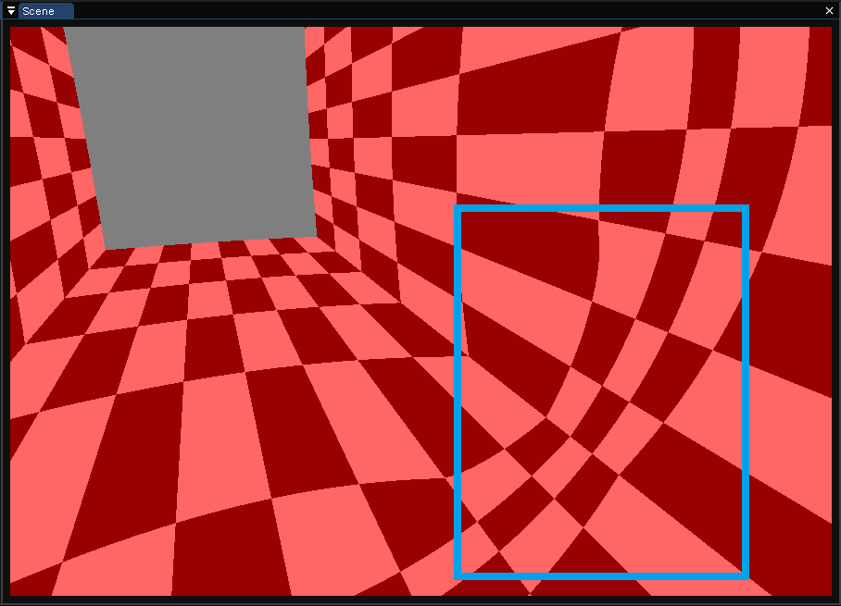

On the right corner we can see marked in a blue rectangle how the texture pattern is being bent in a circular pattern that is caused by the ray deformation method. Since it deforms the rays in a radial manner it causes the rays to form circular patterns. The effect is being aggravated by the texture that is being used by the meshes.

As in the mirror problem, removing or reducing this effect implies limiting the amount that the rays can be deformed thus it will not be removed, since this effect could also be hidden by using repetitive and granular textures without straight lines.

## Development: Portals edition and previsualization tools

### Requirements

In order to allow users to experiment with portal design experiences, a set of portal edition tools and previsualization methods will be added in order to allow the user to visualize the portal space. The portals will have an option to organize their connections using colors.

### Design

**Create portal component class:** Create a class with all the variables and functionality needed: Save and Load, initialize, update, mesh (shape of the portal), connected portal….

**Figure 37 Component portal class UML**

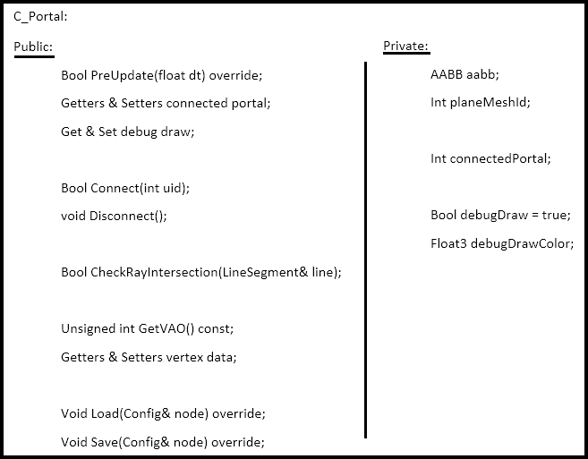

**Add editor functionality:** A button to add a scene node with a portal component will be placed in the *Add* drop down menu and the inspector will display and allow the user to select a connection for the portal and a color picker to choose the color of the portal previsualization lines.

**Portal previsualization:** Adapt the method to preview draw the aberrations in order to accept portals would be fast to implement and very efficient.

### Implementation

**Create portal component class:** Created as a child of the component class, it has an ID to the mesh resource that represents its shape (rectangle). This method can be easily changed in order to allow the user to select the shape of the portal, but was not implemented due to time constrains and the inability to ensure FPS stability.

The shape of the portal will be affected by the transform component the same way a mesh would be affected, allowing to move, rotate and scale the portal dimensions using the gizmos or changing its values in the inspector.

**Add editor functionality:** Using the ImGUI functionality, the button to add a scene node with a portal component was added, and a new collapsing header that displays its values and allows to choose the game object that the portal will connect to.

Since portals can only be connected to game objects that have a portal component, the application will log an error message if the user tries to connect a portal with a non-valid game object.

**Figure 38 Portal editor**

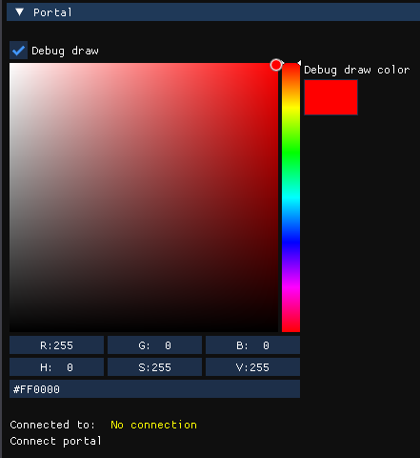

**Portal previsualization:** After rendering the aberrations in the preview rendering pass the portals were drawn using the OpenGL line polygon mode.

**Figure 39 Portal preview draw**

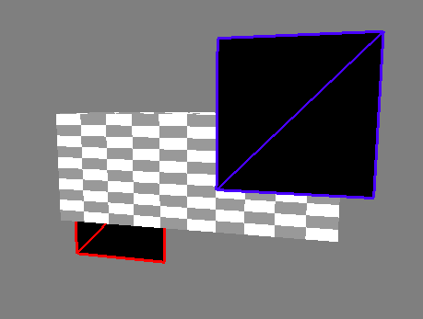

The colored rectangles represent two different portals, we can appreciate that the depth perception is working properly since the red portal is being occluded by the object in front of it. The two black rectangles are caused by the raytracing rendering not being able to correctly work with the portal vertices, this will be solved when we implement a rendering method for the portals.

### Cleaning & Optimization

As stated before the previsualization method is very fast so the performance has not been affected.

### Validation

Currently the engine can create, save and load portals in the scene. These portals can be moved, rotated and scaled using the gizmos, and their data can be modified through the inspector.

The previsualization method is working as expected and hasn’t affected the performance of the application.

As in the aberration component, the portal code is ready to work with meshes since the only functionality needed is to enable the user to change the mesh resource that the aberration is using. Despite being a feature out of the scope of the project it is a possible future expansion.

## Development: Portal ray transformation and camera teleportation

### Requirements

Functionality that will displace the rays once they collide with a portal to the location of its connection and rotate the rays in relation to the portal and its connection.

If the camera intersects with a portal it shall be transformed as the camera rays in order to create the illusion that the space is connected.

### Design

**Pass portal data to the GPU:** The method will be the same that is used to send the aberrations data to the GPU.

**Transform camera rays:** Once the rays collide with a portal, we will calculate the point of collision and find that location in the connected mesh space and cast a ray from that position. The new ray will be rotated in correspondence with the connected object.

**Camera teleportation:** The camera will save its previous position and create a line segment with its current location, this line segment will check for intersections with all the portals in the scene and if it does intersect with a portal the camera will be transformed the same way a camera ray would.

### Implementation

**Pass portal data to the GPU:** Exact same approach as described with the aberrations but instead of sending the deformation direction a reference to the connection will be sent.

**Transform camera rays:** The method to test ray collisions was adapted to check for portal collisions, following the same approach that was used with aberrations.

Once a ray collided with a portal, its collision point would be multiplied by the inverted transform of the portal to have the location in mesh-space, then this point would be multiplied by the transform of the connected portal finding the new ray origin. Once the ray origin has been found, the ray that intersected the portal is multiplied by the inverted rotation part of the portal and then multiplied by the rotation part of the connected portal.

**Figure 40 Portal ray deformation**

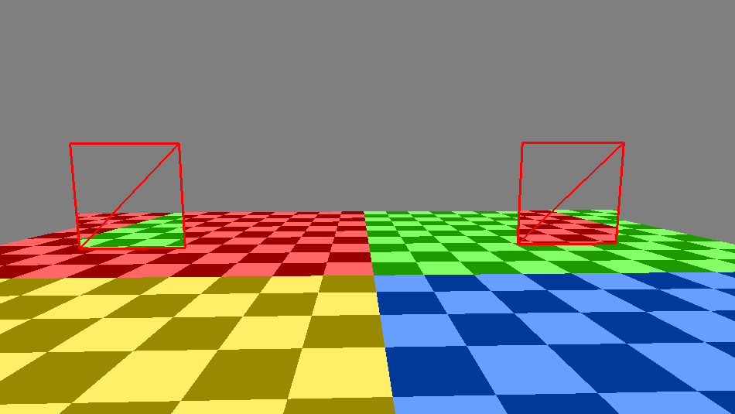

In this image we can observe how the connected portals are displacing the rays correctly, causing both portals to show the geometry from their perspective but maintaining the ray’s direction.

**Camera teleportation:** Since the mesh resources already have functionality to check for line segment intersections it was reused to find if the camera intersected with a portal.

When the camera traverses a portal, its position will be multiplied by the inverted transform of the portal to locate its position in geometry-space and then multiplied by the transform of the connection to find the camera’s new position. To rotate the camera accordingly its forward vector will be multiplied by the inverted rotation part of the portal transform and then multiplied by the rotation part of the connection transform.

This creates a seamless teleportation effect that is unnoticeable by the user.

### Cleaning & Optimization

The render shader was cleaned and modified to reduce branching when checking for intersections between the camera rays and the geometry, aberrations and portals of the scene.

The portals are less performant demanding than the aberrations but still GPU intensive.

### Validation

The camera and its rays are correctly transformed seamlessly when they intersect with a portal creating the illusion that different spaces are connected.

**Figure 41 Portal connecting to a different room**

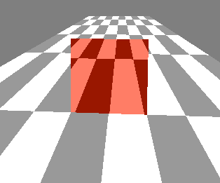

## Development: Demo scene creation

Several scenes were created in order to showcase the possibilities of non-Euclidean spaces and serve as an introduction to start editing and creating scenes in the engine.

### Aberration room

In this scene we can find a room separated into 2 spaces by a black wall, in each one of these spaces is located an aberration that compresses the space in different axis. On the left we can see an aberration that compresses the x coordinate and on the right how it compresses the y coordinate.

**Figure 42 Aberration room screenshot**

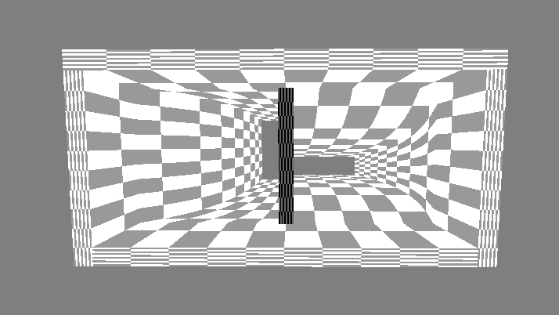

YouTube video: <https://www.youtube.com/watch?v=ylgV2R-9cLk>

### Aberration tunnels

This scene is composed by 4 tunnels with the same width, height and length but are affected by different aberrations.

**Figure 43 Aberration tunnels screenshot**

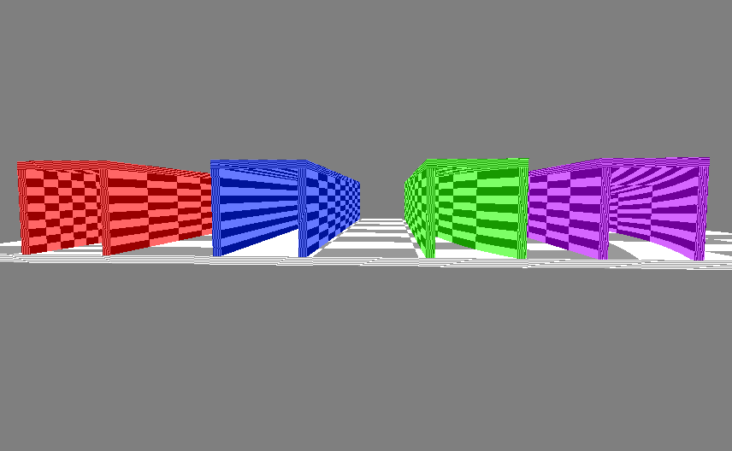

The red tunnel is compressing the space in the z axis, causing it to be shorter from the interior and thus faster to traverse.

The blue tunnel is enlarging the space in the z axis, causing it to be larger from the interior and thus slower to traverse.

The green tunnel is compressing the space in the x axis making it more narrow.

The purple tunnel is compressing the space in the y axis reducing its height.

YouTube video: <https://www.youtube.com/watch?v=AfMQ4SRBrhk>

### Geometry changing room

This scene seamlessly connects two different rooms with differently colored walls and geometry using a portal located between a wall and a column.

This showcases de possibility to compress an infinite amount of space (rooms) in small scenes which as stated before could become very useful for VR game development.

**Figure 44 Geometry changing room screenshot**

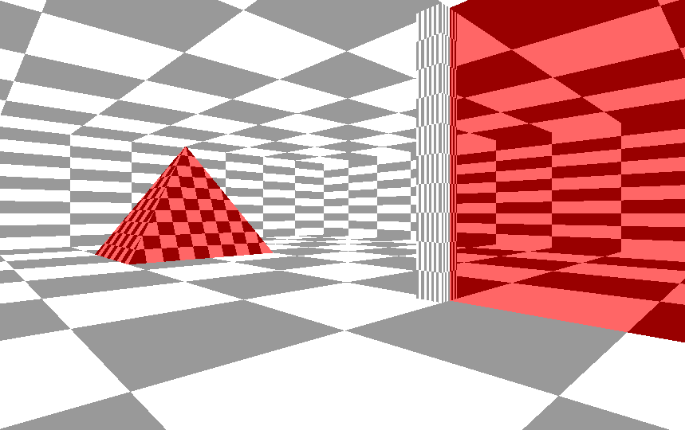

YouTube video: <https://www.youtube.com/watch?v=-jLyBDFaprc>

### Multi-room house

This scene seamlessly connects different rooms with portals in an impossible manner (rooms that after being looked at by the outside should not exist, traversal of the room that changes previous locations and orientations…).

**Figure 45 Multi-room house screenshot**

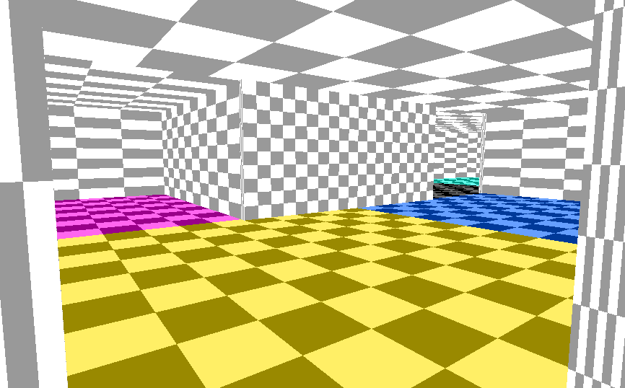

YouTube video: <https://www.youtube.com/watch?v=2mKEJQ1iht4>

# Conclusions

# Bibliography

Möller, T., & Trumbore, B. (1997). *Fast, Minimum Storeage Ray/Triangle Intersection*. Retrieved from https://cadxfem.org/inf/Fast%20MinimumStorage%20RayTriangle%20Intersection.pdf

Bogomolny, A. (1996). *Cut the knot*. Retrieved from http://www.cut-the-knot.org/triangle/pythpar/Fifth.shtml

CNLohr. (2011). *Youtube*. Retrieved from https://youtu.be/0pmSPlYHxoY

DigiDigger. (2017). *Youtube*. Retrieved from https://youtu.be/_SmPR5mvH7w

Gerdelan, A. (2016). *An Introduction to Compute Shaders*. Retrieved from https://antongerdelan.net/opengl/compute.html

Khronos Group. (n.d.). *OpenGL Overview - The Khronos Group Inc*. Retrieved from https://www.khronos.org/opengl/

Kuri, D. (2018). *GPU Ray Tracing in Unity*. Retrieved from http://three-eyed-games.com/2018/05/03/gpu-ray-tracing-in-unity-part-1/

L. Cook, R., Porter, T., & Carpenter, L. (1984). *Distributed Ray Tracing*. Retrieved from https://artis.inrialpes.fr/Enseignement/TRSA/CookDistributed84.pdf

Lapere, S. (2015). *Raytracey*. Retrieved from http://raytracey.blogspot.com/2015/10/gpu-path-tracing-tutorial-1-drawing.html

Marschner, S. (2017). *Textures and normals in ray tracing*. Retrieved from https://www.cs.cornell.edu/courses/cs4620/2017sp/slides/06rt-textures.pdf

Miller, G. (2018). *Encyclopedia*. Retrieved from https://www.encyclopedia.com/science-and-technology/mathematics/mathematics/non-euclidean-geometry

*Non-Euclidean Worlds Engine*. (2018). Retrieved from https://www.youtube.com/watch?v=kEB11PQ9Eo8

Nvidia. (n.d.). *Nvidia developer*. Retrieved from https://developer.nvidia.com/rtx/ray-tracing#:~:text=Ray%20tracing%20is%20a%20method,to%20pioneer%20the%20technology%20since.

Pitici, M. (2008). *Non-Euclidean Geometry Online: a Guide to Resources*. Retrieved from http://pi.math.cornell.edu/~mec/mircea.html

Quilez, I. (n.d.). *Iquilezles*. Retrieved from https://iquilezles.org/index.html

*Scratchapixel*. (2009). Retrieved from https://www.scratchapixel.com/index.php?redirect

Varun R. (2013). *Youtube*. Retrieved from https://youtu.be/YvU-srHhQxw

Vinícius Silva, Tiago Novello de Brito, Luiz Velho, Djalma Lucio. (2019). *Visualization of Non-Euclidean Spaces using Ray Tracing*. Retrieved from https://www.researchgate.net/publication/337472155_Visualization_of_Non-Euclidean_Spaces_using_Ray_Tracing

Vries, J. d. (2014). *Learnopengl*. Retrieved from https://learnopengl.com/Introduction

Zwan, J. v. (2020). *Linear Interpolation along a Triangle with Barycentric Coordinates*. Retrieved from https://observablehq.com/@jobleonard/linear-interpolation-along-a-triangle-with-barycentric-co